EVIDENCE BASED DESIGN
TherAplay
Kelsey Park | Ball State University | IDES 424 | Fall 2021
Organization is important and separate areas

Background
TherAplay is an Occupational and Physical Therapy center for children with limited function and mobility. They specialize in hippotherapy as a practice. Hippotherapy is a physical, occupational, and speech therapy that utilizes the movement of a horse to provide motor, and sensory input. It is used for
patients with physical and mental disorders.
between files, books, storage, and desks is essential for cleanliness. Having areas to
store important materials separate from work spaces helps keep items organized, secure, and private.

Interior windows to connect appropriate rooms is desired for increased visibility and connectivity. Open spaces with flexibility in purpose and function is also a consideration. Windows and natural light are favored over artificial lighting.

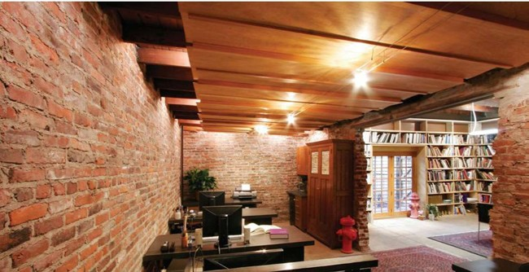
Open concept and open spaces, allowing for personal space between families, is desired heavily. This will help with conversing with people and not increasing volume levels as well as avoiding overcrowding and inapproriate distractions for the children attending TherAPlay.

Renovation Take-Aways (Current) From previous stages of this project with TherAplay, many conclusions and decisions have been made.
The client, TherAplay, wants a very natural interior environment that reflects the calm attributes of the outdoors. The natural elements will be rustic, not polished. The spaces are not to look like a polished cabin and should be very inclusive and comforting to the people occupying the space.
Surveys were conducted to determine what the client wants in the space. The take-aways from these surveys are summarized below: Exposed physical elements are desired to bring character into the space and add pleasing details and positive distractions while observing the interior space. Privacy from personal areas is also important, but maintain the integrity of natural and barn-like features.

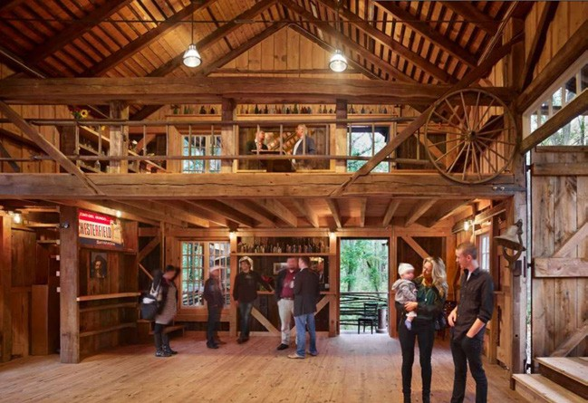
Natural elements with contrast is also important for the children so that the space is visually pleasing and clear. The contrast of colors in materials and items will help them compartmentalize elements in the space around them.

1

RESEARCH

Sensory Integration: Materials, Color, and Furniture
Sensory Integration with Cerebral Palsy: Cerebral palsy results in abnormal degree of sensory processing (increased of decreased). Over sensitive and under sensitive feelings can lead to mental and physical distractions
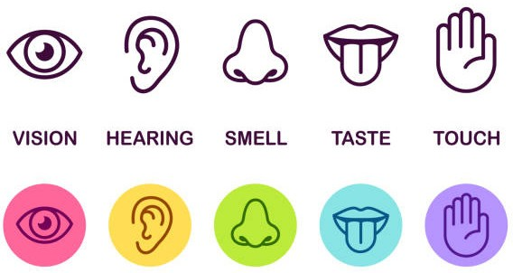
or fatigue.

Sensory Integration works to improve different senses by:
- VISION
-neon, patterned, and florescent paper
-colored lights, holiday lights
-wind-up toys
Colors should be introduced for strengthening vision with contrasting colors. Overall muted tones are preferred with pops of color through furniture or patterns to provide a focal point and place of interest for the children to focus on.

Sensory integration helps children use their senses appropriately and self-regulate.
Example: Lack of sensitivity to touch can result in inaccurate perceptions of weight and texture.
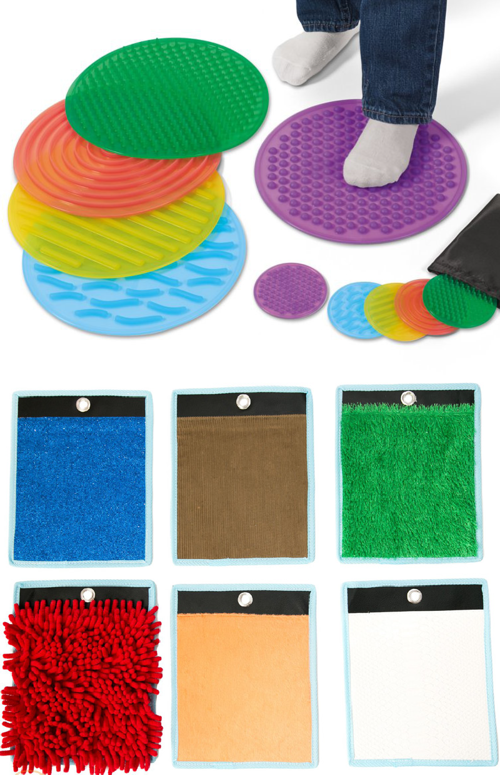
Different levels of sensory:
  - Over responsive = avoidance, cautious and fearful
  - Under responsive = withdrawn, passive or
difficult to engage
  - Sensory seeking = implusive and take risks
- HEARING
-water trickling
-music (chimes)
-repetition
- TOUCH
-hard = rocks, floors, counters
-soft = fur and feathers
-surfaces = sticky, rough, pointy, and smooth
- MOBILITY
-throwing a ball
-bouncing on a ball
-swinging
-sliding
Mobility in furniture is important, whether the furniture piece moves or the piece requires the individual to move. Swings, exercise balls, walkways, and stairs are beneficial to improve the individual’s mobility.
Take-Away
It is important to incorporate a variety of materials and activities that challenge the five sense. Introducing new feelings, sounds, and subtle visual changes is important to help balance out the levels of sensitivity.
Providing ways for childrent to see light and colors differently (by their control) is a great way for them to gradually de-sensitive their sense to what could be troubling to their learning.
(Stern, 2020.) 2

RESEARCH

Lighting Effects with Autism: Lighting and Color
Lighting Effects with Autism:
Lights with mellow colors (like blue) can help kids relax and become creative. Harsh and flickering lights can confuse and harm them. Natural light is also extremely important to help regulate their circadian rhthym.

Therapy Purposes:
-Lights with 10,000 lux and emit no UV light are optimal.
-Best to do light theraping in the morning as they are just waking up.

Do not use florescent lights!

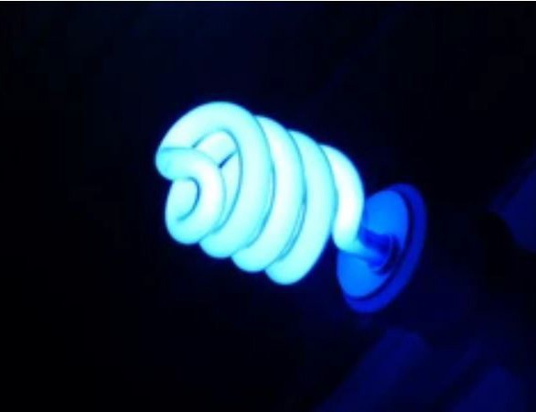

Light is made up of electromagnetic waves and each hue interacts with neuropathways in the brain.
Colors affect mood, behaviors and performance.
Studies decoding the physiological effects of different hues have shown changes in sensory sensitivity, blood pressure, heart rate, and brain development.

Colors like red, orange and yellow provide
a high level of stimulus and increase energy and encourage creativity. This is good for kids with autism.

Green helps to relax the nervous system and lessens feelings of stress. It seems to help with communication and developing speech skills. Cool tones may be a good choice for individuals where reducing stimulation is a high priority, such as those with ADHD or the
hypersensitive variation of Autism.
Take-Away
Light therapy is extremely beneficial to
children with autism specifically.
Lights can generate a specific emotion or
mood based on the color and intensity. Natural light is most effective and beneficial, so mimicking natural light through artificial light is most comfortable in an indoor space. Allowing people with autism to adapt to lights of different colors and brightnesses
is helpful, as long as florescent lights are avoide since those types of lights often increase anxiety and stress.
(Kimble, 2020.)
(“How Light Can Help Autistic Children.” 2020.)

Designing a Space for Someone with Autism: Acoustics and Wayfinding
Designing a Space for Someone with Autism:
Often times, simplicity is better. Design factors to heavily consider:
- Acoustics:
-provide better sound insulation to minimize distraction and disturbances.
- Lighting:
-small areas of bright colors.
-larger areas of light unsaturated earth tones.
- Spatial Reasoning:
-organization.
-storage to minimize clutter and distractions.
-wayfinding through repetition.

3

RESEARCH

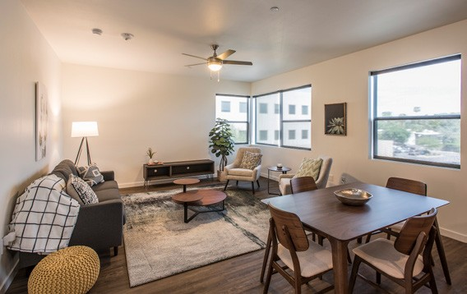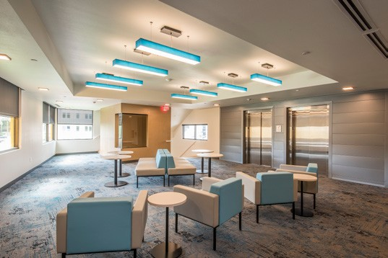Natural elements are beneficial as well, promoting calmness and a sense a familiarity and grounding. Designing a floral wall
Colors used throughout the apartment were chosen to promote calmness and relaxation. The selected colors were blue, grey, green, tan, and lavendar.

The design team also carefully included a repeated material palette strategically
throughout all spaces to increase familiarity and comfort in public and private rooms.
Subtle colored visual paths were used to help
with wayfinding.
Take-Away
Acoustics are important to minimize
distractions from outside areas and decrease pain or confusion. Buffering out harsh noises from outside will help keep children with autism focused.
Wayfinding can be done in a way where color is repeated in an organized way to help them follow a trend or path through the space. Color categorizing areas is effective for this. Organization is important to also help minimize stress and distractions.
and including foliage throughout spaces stimulates health and well-being.
Natural materials in terms of fabrics, paints,
(“Four Keys to Designing Austistic Friendly Spaces.” 2020.) and other specifications are often chemical

CASE STUDY
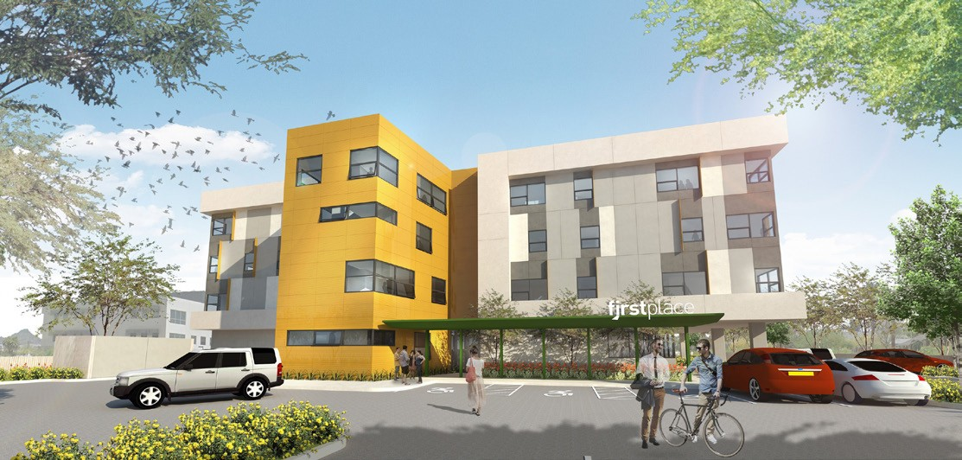
free and have low toxicity levels.

Designing for the Autistic: First Place Apartments, Arizona
The First Place Apartments are apartments
that were designed in Arizona to help adults with autism move to live more independently into a specialy designed apartment complex.
The design of the apartments was curated for people with autism, so that they may comfortable use the space. Many elements were implemented to make sure the design would not be disturbing, distracting, or
Take-Away
Natural tones are relaxing and soothing,
offering familiarity to what is outside. Colors are chosen to create a feeling of calmness and relaxation. Repeating colors and patterns in different rooms makes the spaces feel familiar and inviting. Subtle colored visual paths help with wayfinding throughout the space in addition to the repetative patterns. Natural materials and elements help clean the space and promote well-being.
overwhelming.

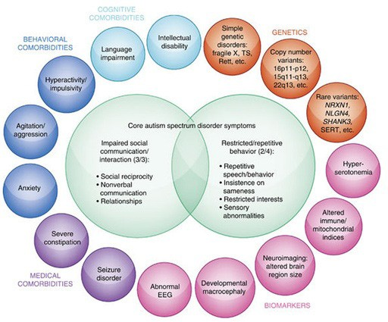
(Denhardt, 2017.) 4

TherAplay In-Person Observations

OBSERVATION NOTES
To understand what is needed for the children, and what would be most beneficial for their therapy, three visits were arranged to TherAplay in Carmel, IN.

The first visit was a tour of the facility, the new renovation, and the areas that our focus will be in (new gym and the arena).
Take-aways from first visit/tour:
- Children learn daily skills
- Practice physical therapy and occupational therapy
- Colors, materials, and other sensory related design elements must be carefully considered

The second visit was for a personal observation, and observing the behavior of the children in the arena (hippotherapy) and in the gym. This observation helped understand common behaviors of the
children and to better understand what types of activities they do and practive while at TherAplay.
Take-aways from first observation:
- Practive fine motor skills and daily routines
- Muted colors make them calmer and less distracted
- Noise can be distracting

Discussion With TherAplay Employee
While at TherAplay, some main ‘needs’ in terms of equipment pieces, furniture, and activities for the children were provided to us by a TherAplay employee.
She mentioned that activities along the wall of the arena for the children to interact with while they rode horses would be beneficial.

Some ideas based off this were:
- Mail boxes
- Cork board / Magnetic board
- Peg board

Moving into the gym area, she mentioned some pieces that would be beneficial to the children to practice in there that would transfer to real-life skills.

Some ideas based off this were:
- Sensory wall
- Swing
- Stairs
- Balance Chair

The third visit was for another observation, but this observation focused on furniture pieces and equipment used by the children. We observed the use and functions of a specific piece of equipment in the gym area.
After considering the needs and possibilities
for what to create to be in TherAplay, I decided to combine a few ideas into one... I plan to create a stair piece that also has a small sensory wall at the top.
This will be able to practice both physical therapy in the act of walking up steps, and work on fine motor skills and sensory adaptation with elements on the sensory wall.
Take-aways from second observation:
- Enjoy fun designs and colors
- Most common activites include life skills
- Practice their independence
- Enjoy games
5

CONCEPT
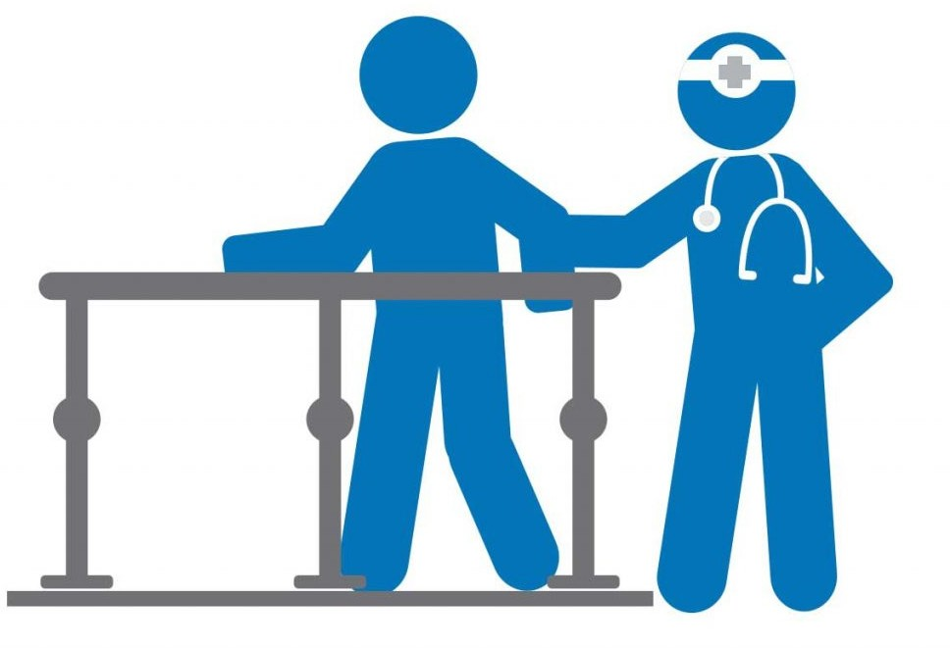

To achieve the needs of the clients, the concept behing my design is to create a dynamic piece that meets both the needs of physical therapy and sensory adaptations.

Combining the elements of a physical therapy piece that practices muscle control and mobility, with a piece that also contributes to sensory integration.

To acieve both of these elements and goals in a furniture piece, I decided to use a stair piece for the physical therapy piece to integrate the concept of children walking up and down stairs independently, assisted by a hand rail or therapist. This is an important skill since stairs are encountered often throughout daily life. Then, to integrate an element of sensory, I will incorporate a sensory wall and activities of some kind that will be attached or built into the stair case.

6

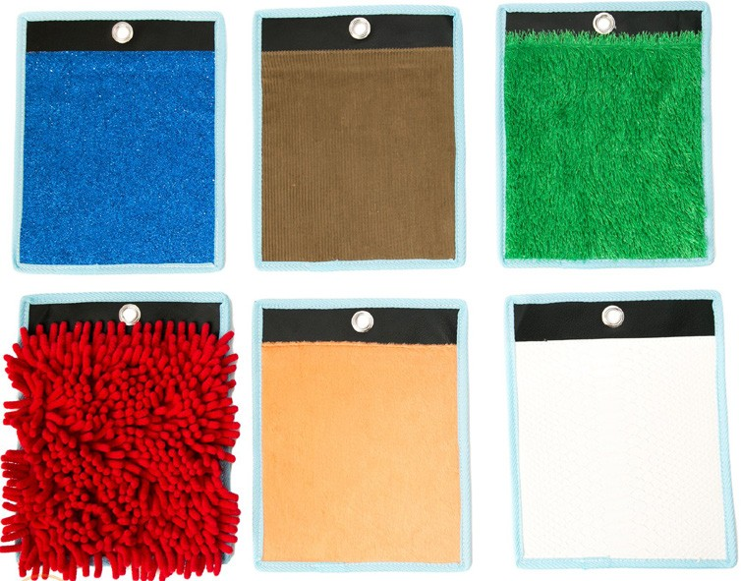DESIGN IDEAS

Client Needs / Wants
-Furniture Piece
-Elements that promote daily exercises
-Peg board wall in arena
-Activities for fine motor skills
-Safety considerations

Furniture Idea
Combine the designs of a play stair set, with
the option of storage, as well as an interactive
wall/side.
The stairs would provide a physical obstacle for kids to practice muscle control on. The option of have storage offers organization and cleanliness to the space without taking up other purposeful space in the room. An interactive side/wall would allow the stairs to have functions for physical and mental/
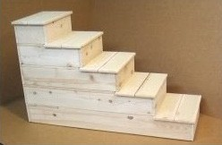cognitive practices. Shapes, pegs, and lights of different kinds could be combined into the element for an interactive station.
Basic Structure

The addition of adding elements of different materials; fur, feathers, leather, wood; will help with feeling and touch as well.

The piece itself is focused on physical therapy by having children walk up steps using their muscles to balance and step up.
Walking up and down stairs is a life-skill, something that TherAplay wants to focus on strengthening in each child!

Preliminary Sketches

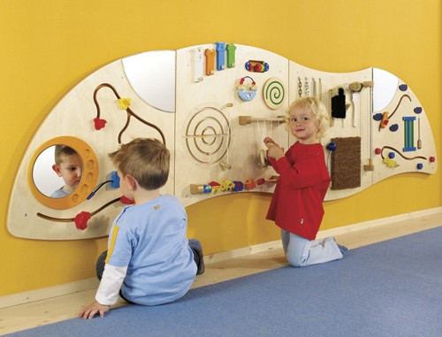
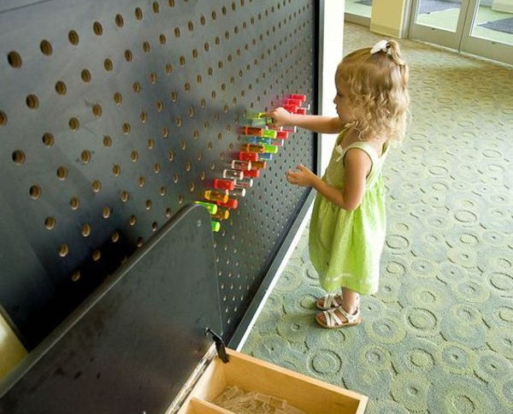
Interactive Wall Examples
These photos demonstrate interactive items that would work on fine motor skills and cognitive practices.
Incorporating elements of color and shape will promote visual learning while the movement of pieces throughout the interactive wall will help with fine motor skills.
The steps have been shortened to be less height per step. This is to help the kids really be able to do the stairs on their own without much need of assistance.
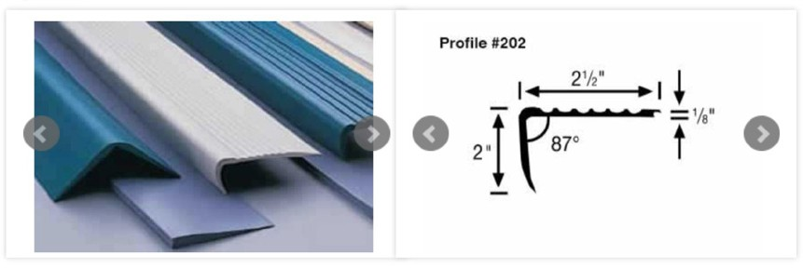
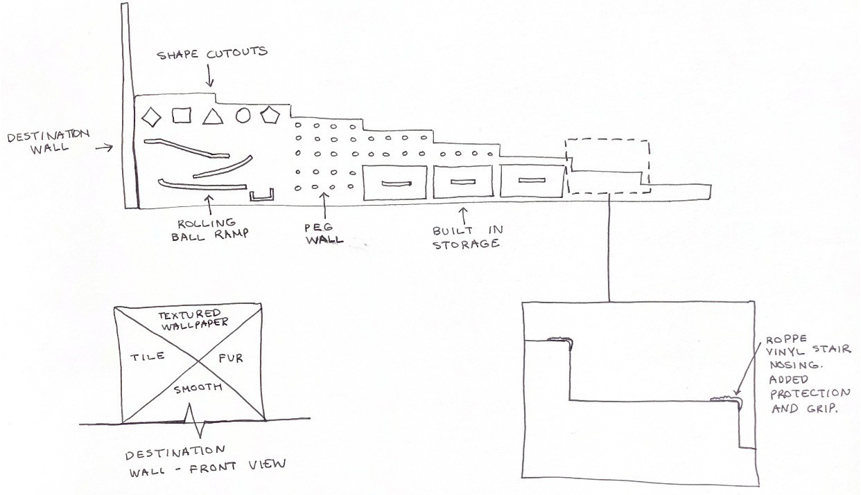This is good practice for their mobility on steps and balancing as they move upwards.

Roppe Vinyl Stair nosing woud add protection to the stair corners, making them less dangerous as children travel up the steps.

7

The therapist for TherAplay will approve all ideas and provide suggestions based on knowledge of what is important and essential for the children.

Jessica Boram, the therapist, received my initial ideas and preliminary sketches for the furniture piece [as seen above].

Her feedback is crucial to moving forward as certain standards may be different when installing pieces for kids with disabilities.

Take-Away
Moving forward with the design development, consider and add the following:
DESIGN IDEAS
The end destination of the stairs is a texture wall, incorporating different types of materials for the children to feel.
The different materials would introduce them soft, hard, smooth, and course surfaces.
This is important so they have a sense of touch and feeling.

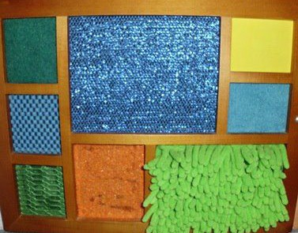

Feedback Email:
Hi Kelsey!

I love the stair option with storage solution! The stairs will be placed up against the wall so we will only have access to one side and we would need railing on the side with the storage for safety. Ideally the left side of the stairs will be placed up against the wall. The ceiling height is also limited to 8 feet, so we
will need to take that into consideration when planning the final height of the top platform. The steps will also need to be standard ADA height and depth to complete standardized testing. Thank you so much for your hard work!

Thank you,
Jessica Boram PT, DPT Physical Therapist
9919 Towne Road, Carmel, IN 46032
Main office (317) 872-4166 www.childrenstheraplay.org
Therapist’s Feedback

-Railing on the outside edge of the stairs for support
-Leave minimum of 5’-0” of space from the top of the platform to the ceiling of 8’-0”; making the platform no more than 3’-0” in height
-Steps will need to be standard ADA height and depth to complete standardized testing

8

Further Research

REFINED DESIGN
Taking in to consideration the feedback of
the therapist, it is important to appy ADA standards required for this furniture piece.

STEPS:
The ADA standard for a stair depth, or tread, is minimum of 11 inches.
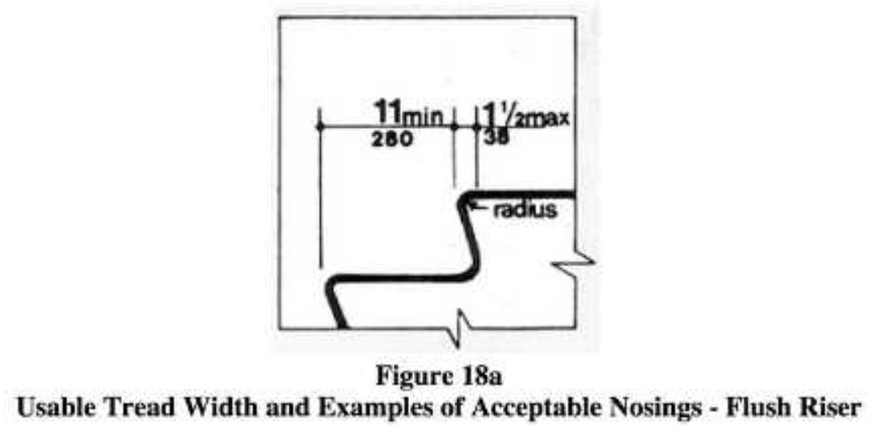
The riser height standard is minimum of 4 inches and maximum of 7 inches.

HANDRAILS:
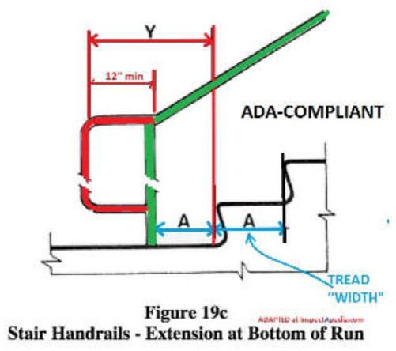
Handrails are to be continuous along the steps. There shall be a 12 inch minimum extension at the bottom and top of the stairs.

Handrails are also required to be 31.5 inches above the stair nosing when applied to one side.
Per my design, it will be placed up against a wall, so only one handrail is required on the exterior side of the stairs.

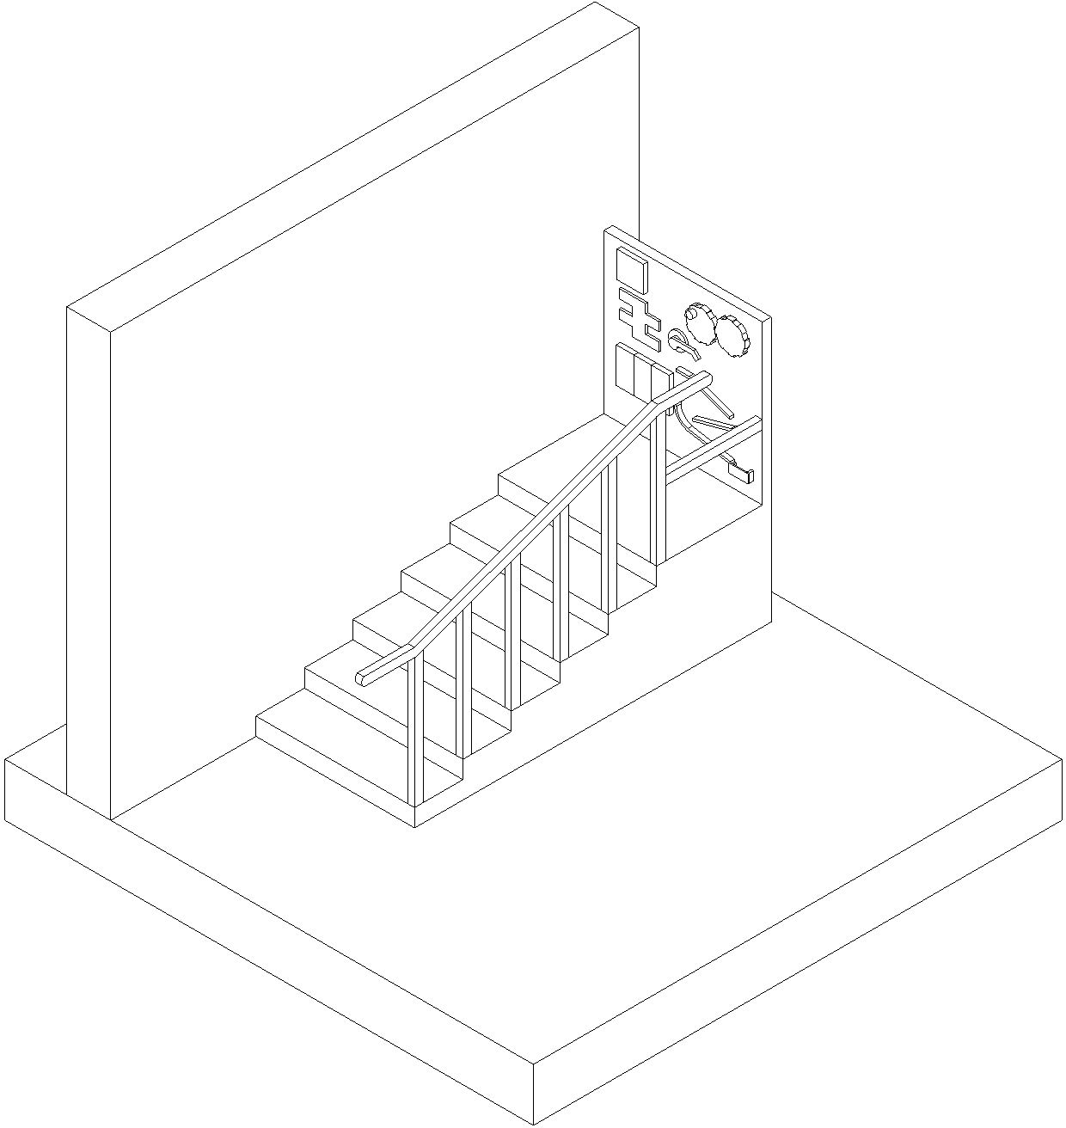
Shown above is a 3D depiction of the piece done in Revit, with the added elements requested by the therapist.
This 3D model does accurately depict the size next to the 8’-0” wall.
The stair width is the standard 36 inches. Since the sensory wall was placed as the ‘goal’ and destination at the top of the stairs.

Storage drawers will help hold other activities and equipment, and help children with their skills to open and close the drawers.

The option to make the stair piece three separate pieces that can be put together for easy transportation are ideal.
The piece would be divided as the stairs, the platform, and the sensory wall.

The railing would be able to be inserted into

These standardized dimensions will be applied the stairs with slots where they would fit.
to the required dimension to not have the top platform higher than 3’-0” in the space.

9

Further Research

DESIGN DETAILS
Now that the stair piece has been developed into a rough model and depicted into shape, size, and design elements, design details can be specified.
MATERIALS:

The stair case will be made entirely out of Spruce Wood, unless noted otherwise.

The sensory wall will include elements such as: fur, brick texture, sparkle texture, metal, mirror, and wood. The sensory wall will also contain colors such as blue, purpe, green, and muted red. These colors will be able to capture
JOINTS AND CONNECTIONS:
The construction documents provide information to build the piece of furniture as well as a realistic rendering of what the piece would look like in a space with 8’-0” ceilings, same as the gym at TherAplay.
the children’s attention, focus, and interest without being overwhelming.

All these details are explained and depicted clearly in the Construction Documents for this furniture piece.

A material realistic image of the furniture piece is shown below.

Following this page are the set of Construction Documents for the building of the stair piece and sensory wall.

The piece will be connected through nails, screws, and nail glue for permanent connections.
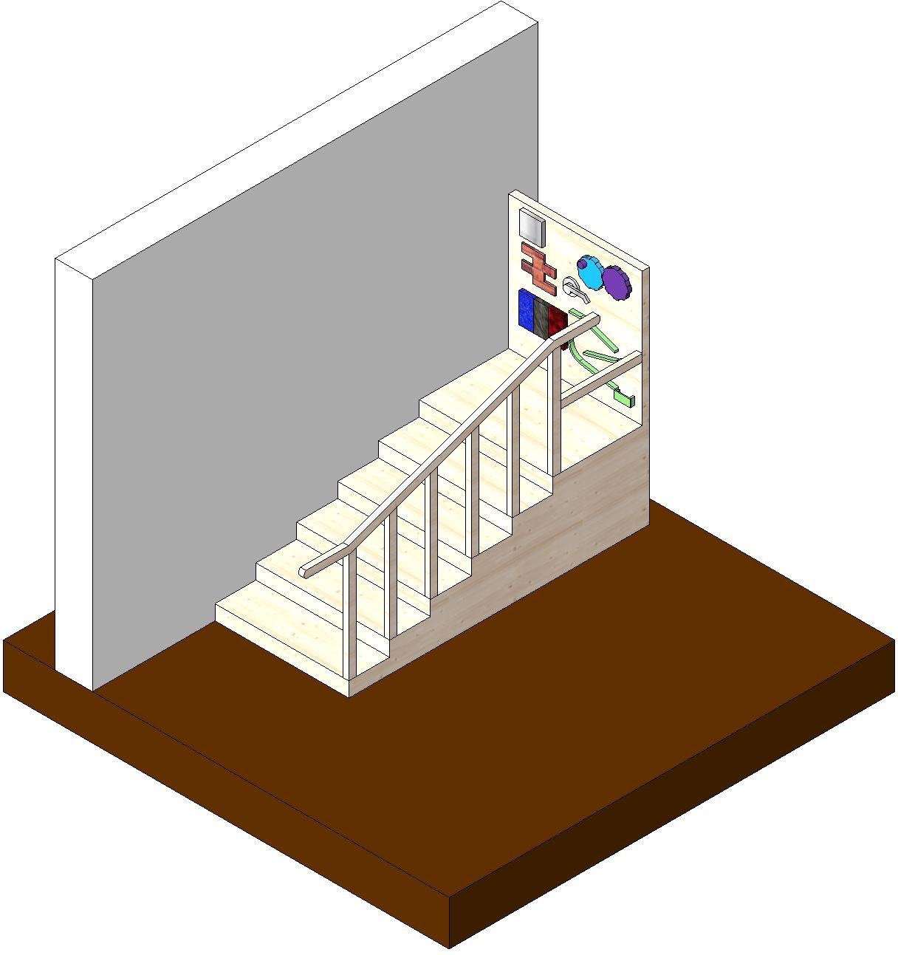
For areas of connection that can be taken apart during transportation, pegs and holes will be used for sliding and locking into place.

10

SENSORY STAIR FURNITURE PIECE

INDEX

A101 - PIECE A, STAIR PIECE A102 - PIECE B, PLATFORM PIECE
A103- PIECE C, SENSORY WALL PIECE A104 - PIECED, RAILING PIECE

THERAPLAY FURNITURE PIECE PROJECT

CARMEL, IN

DESIGNING FURNITURE FOR OCCUPATIONAL AND PHYSICAL THERAPY PURPOSES

BALL STATE UNIVERSITY
BALL STATE UNIVERSITY IMMERSIVE LEARNING PROGRAM

GENERIC FURNITURE PIECE NOTES:
IMAGE NOTES:
IN THE ABOVE 3D MODEL IMAGE, THE STAIR PIECE IS SHOWN PLACED UP AGAINST AN 8 FOOT WALL..

FURNITURE PIECE DETAILS:
THE PIECE IS TO BE CONSTRUCTED OUT OF SPRUCE WOOD OF 3/4 INCH THICKNESS, UNLESS NOTED OTHERWISE.
.. NOT SHOWN IN THE 3D VIEW ARE THE CONNECTING ELEMENTS AND JOINTS BETWEEN DIFFERENT PIECES. ALL PIECES ARE CONNECTED BY EITHER SCREWS, NAILS, AND/OR NAIL GLUE.

THE PIECE IS CONSTRUCTED IN FOUR SEPARATE PIECES FOR EASE OF TAKING APART FOR TRANSPORTATION. THE PIECES ARE STAIRS, PLATFORM, SENSORY WALL, AND RAILING.THE VDs FOR EACH OF THESE PIECES ARE INCLUDED IN THAT ORDER.

SENSORY WALL DETAILS:
THE SENSORY WALL IS MADE UP OF SEVERAL ELEMENTS FOR FINE MOTOR SKILLS AND SENSORY FUNCTIONS. SHOWN IN THIS PARTICULAR DESIGNS ARE ELEMENTS SUCH AS:
-MIRROR
-BRICK TEXTURE
-THREE VARIETY TEXTURE MATERIALS
-DOOR HANDLE
-COG WHEELS
-BALL RAMP
THE SENSOR WALL PIECES ARE DETAILED ON SHEET A103.

DRAWN BY KELSEY PARK COMPANY BALL STATE
UNIVERSITY

INTERIOR DESIGN IDES 424
FALL 2020

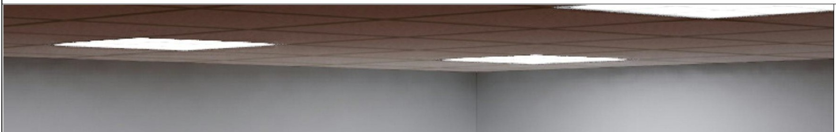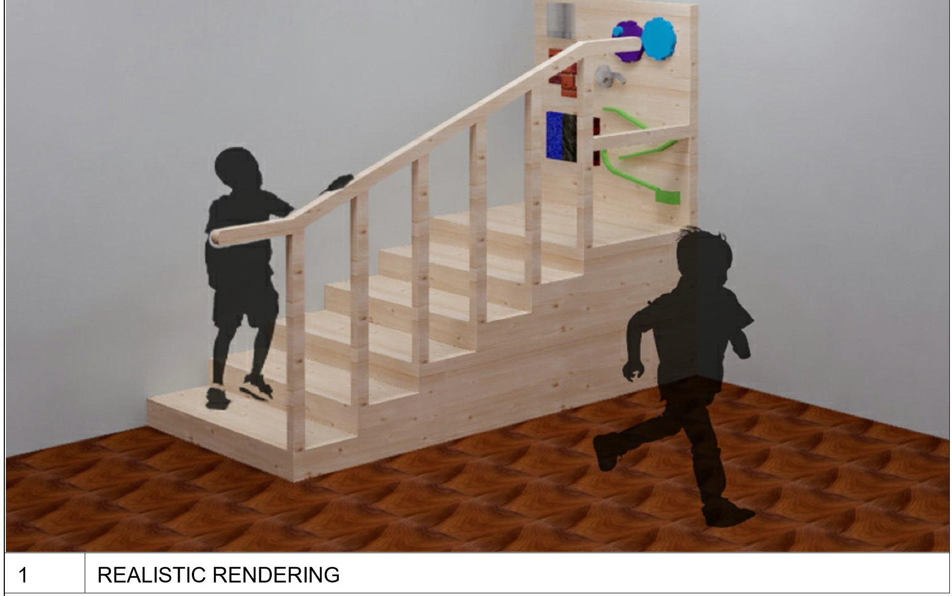
CLIENT THERAPLAY

DATE

SCALE: 1/2" = 1'-0"

SHEET: G100

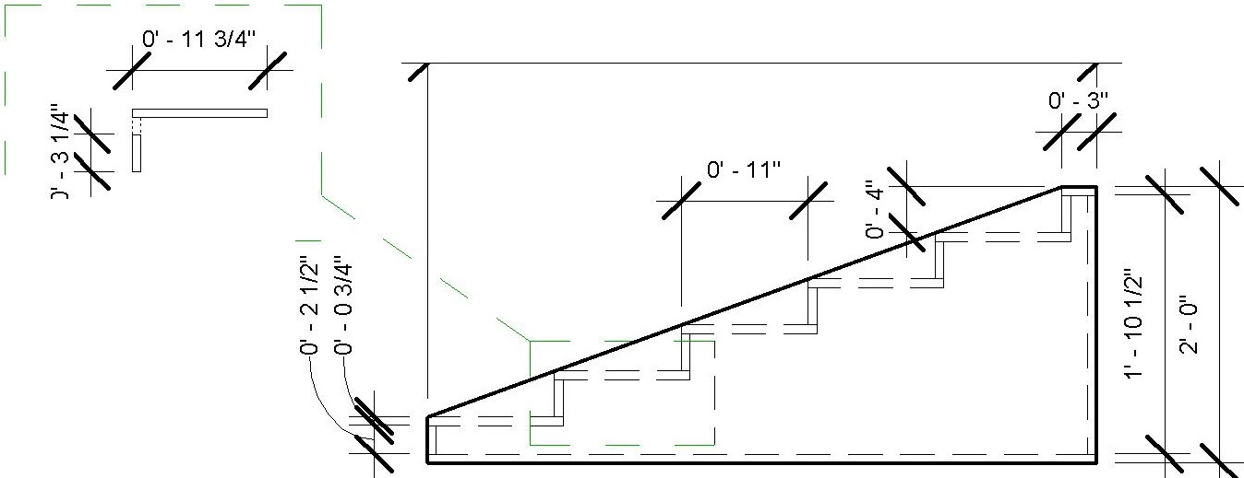
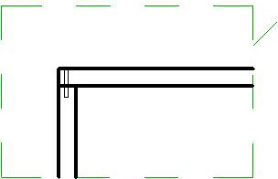
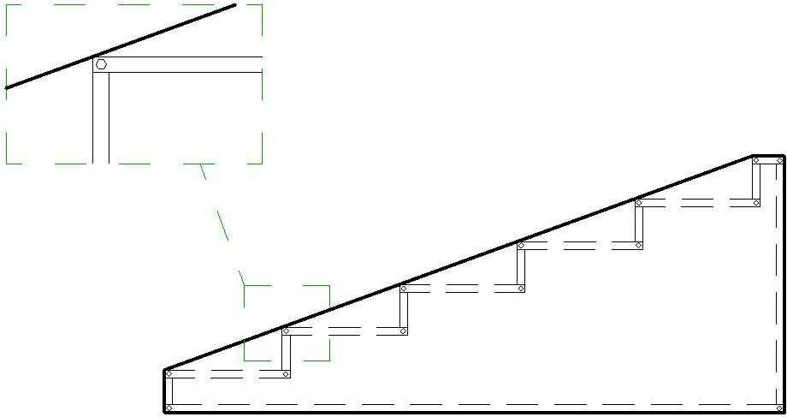
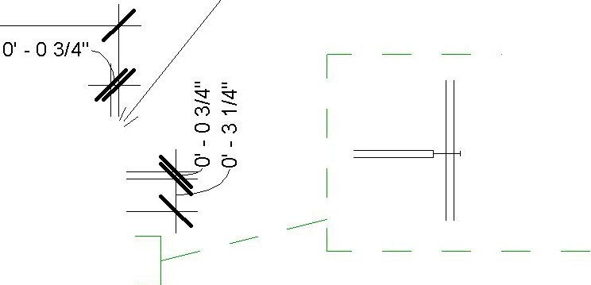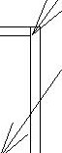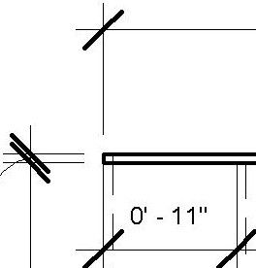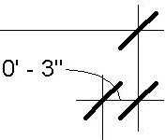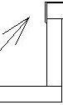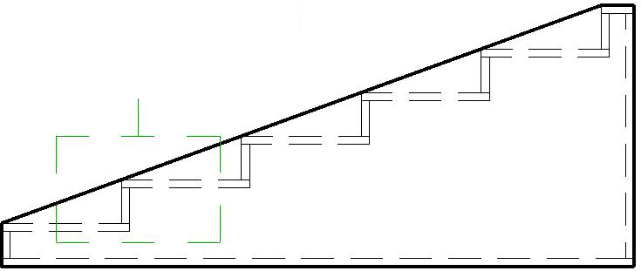
1 4-
st

b

.
,---
L
,, 2' -10 1/2" ,

PIECE A: STAIR PIECE
 |  |  |  | 4' -10" |  |  |  |  | '  b  ' I' | t | 3' - O" |  |  |  |  | 11/ | SIDE PANEL | - 7  STEP AND SIDE PANEL JOINED BY NAIL AND NAIL GLUE.  _J
 |  |  |  |  |  |  |  |  |  |  |  |  |  |  |  |  |  |  | THERAPLAY FURNITURE
 |  |  |  |  |  |  |  |  |  |  |  |  |  |  |  |  |  |  | PIECE PROJECT
 | L _ |  |  |  |  |  |  |  |  |  |  |  |  |  |  |  |  |  | CARMEL, IN
 |  |  |  |  |  |  |  |  |  |  |  |  |  |  |  |  |  |  | DESIGNING FURNITURE
 |  |  |  |  |  |  |  |  |  |  |  |  |  |  |  |  |  |  | FOR OCCUPATIONAL AND
 |  |  |  |  |  |  |  |  |  |  |  |  |  |  |  |  |  |  | PHYSICAL THERAPY
 |  |  |  |  |  |  |  |  |  |  |  |  |  |  |  |  |  |  | PURPOSES
BALL STATE UNIVERSITY
BALL STATE UNIVERSITY IMMERSIVE LEARNING PROGRAM
SIDE VIEW |  |  |  |  |  |  |  | 2 | FRONT VIEW
 |  |  |  |  |  |  |  |  |  |  |  |  | 4' -10"
 |  |  |  |  | SIDE PANEL
 |  |  |  |  | BACK PANEL: WHICH WILL BE
 |  |  |  |  | PLACED AGAINST THE "B" PIECE
 |  |  |  |  |  |  |  |  |  |  |  |  |  |  |  |  | 11 | CUT OUTS IN STEP PIECES, TWO INCH DIAMETER, FOR RAINING INSERT.
 |  |  |  |  |  |  |  |  |  |  |  |  |  |  |  |  | 11 | STAIR RAILING WILL BE MADE SEPARATE (PIECED) TO BE PLACED IN
 |  |  |  |  |  |  |  |  |  |  |  |  |  |  |  |  |  | THESE HOLES AFTER TRANSPORTATION .
 |  |  |  |  |  |  |  |  |  |  |  |  |  |  |  |  | 11 | HOLE CUTOUTS ARE ONE INCH FROM EDGE OF WOOD PANEL, AND
 |  |  |  |  |  |  |  |  |  |  |  |  |  |  |  |  |  | CENTERED FROM FRONT TO BACK.
 |  |  |  |  |  |  |  |  |  |  |  |  |  |  |  |  | 11
 |  |  |  | 0' -0 3/4" |  |  |  |  |  |  |  |  |  |  |  |  | I
 |  |  |  | 2' - 10 1/2====!
 |  | 71 |  |  |  |  |  |  |  |  | • • |  |  |  | • |  | 11
3 | BACK VIEW |  |  |  |  |  |  | 4 | TOP VIEW
DETAILED STAIR NOTES:
5A | ROPPE VINYL STAIR NOSING WILL BE PLACED ON EACH STEP CORNER FOR ADDED PROTECTION AND GRIP AS CHILDREN TRAVEL UP THE STEPS. SIX STRIPS OF ROPPE VINYL STAIR NOSING NEEDED. |  | i | - - -  I  SCA-LE= 1-"i=-1'-0" j |  | 5B |  |  |  |  |  | 5C
 |  |  |  |  |  |  | 1 1  / L " L  I  I |  |  |  |  |  |  | NAILS THROUGH SIDE PANEL INTO STEP PANELS OF WOOD. NAIL GLUE W ILL ALSO BE USED FOR EXTRA CONNECTION SUPPORT. FOURTEEN NAILS NEEDED FOR EACH SIDE OF THE STAIR PIECE. ALSO SHOWN IN IMAGE 101-2.
 |  |  |  |  |  |  |  |  |  |  |  |  |  |  |  |  |  |  | DRAWN BY |  | KELSEY PARK
 |  |  |  |  |  |  | I  I |  |  |  |  |  |  |  |  |  |  |  | COMPANY |  | BALL STATE UNIVERSITY
 |  |  |  |  |  |  | STAIR PANELS CONNECTED THROUGH NAILS AND NAIL ^{I}  GLUE. I  ALSO NAILED AND GLUED  TO SIDE PANELS FOR CL" •'"----= cJ 'o  SUPPORT, AS SHOWN IN  IMAGE A101-2.  THREE NAILS SPACED ALONG EDGE OF BOARD. |  |  |  |  |  |  |  |  |  |  |  |  |  | INTERIOR DESIGN IDES 424  FALL 2020
 |  |  |  |  |  |  |  |  |  |  |  |  |  |  |  |  |  |  | CLIENT |  | THERAPLAY
 |  |  |  |  |  |  |  |  |  |  |  |  |  |  |  |  |  |  | DATE
 |  |  |  |  |  |  |  |  |  |  |  |  |  |  |  |  |  |  | SCALE: 1/2" = 1'-0"
 |  |  |  |  |  |  |  |  |  |  |  |  |  |  |  |  |  |  | SHEET: A101

PIECE B: PLATFORM PIECE

FACING OUTWARD OF WALL.

SIDE VIEW

TOP PANEL FOR KIDS TO STAND UPON.

ONE INCH DIAMETER HOLES IN TOP PANEL FOR SENSORY
WA LL (PIECE C) ATTACHMENT.

4 TOP VIEW

1'-11"
I/
'1

1' -91/2"

1'-11"

- FRONT VIEW

3' - O"
THIS SIDE WILL BE PLACED
AGAINST THE "A" PIECE.

FOUR NAILS USED ON FRONT AND BACK SIDE, CONNECTING THROUGH TO SIDE PANELS.
NAIL PLACED THROUGH BACK PANEL INTO SIDE PANELS.
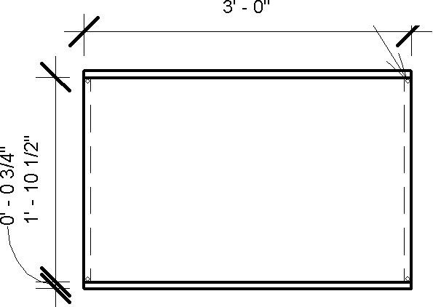

- BACK VIEW

THERAPLAY FURNITURE PIECE PROJECT

CARMEL, IN

DESIGNING FURNITURE FOR OCCUPATIONAL AND PHYSICAL THERAPY PURPOSES

BALL STATE UNIVERSITY
BALL STATE UNIVERSITY IMMERSIVE LEARNING PROGRAM

DETAILED PLATFORM NOTES:

5A

5B NOTE:
ALL 'SIDE' FRAME PIECES ARE A HEIGHT OF 1'-10 1/2". THE REST INBETWEEN THE TOP AND BOTTOM PANELS. THE TOP AND BOTTOM PANELS ADD AN EXTRA 3/4" EACH, MAKING THE TOTAL HEIGHT OF THE
PIECE 2'-0". THE TOP AND BOTTOM PANELS COVER THE PIECE EDGE TO EDGE, BOTH BEING DIMENSIONED AT 1'-11" D x 3'-0" W.

:l • l
L
•
I/
,-1

SIDE PANEL
1'-11"
I/
,-1

SIDE PANEL

BOTTOM PANEL
1' -91/2"
I/
,-1
3' - O"
I/
I/
,-1

DRAWN BY COMPANY

KELSEY PARK BALL STATE

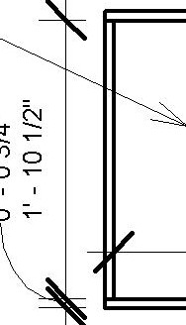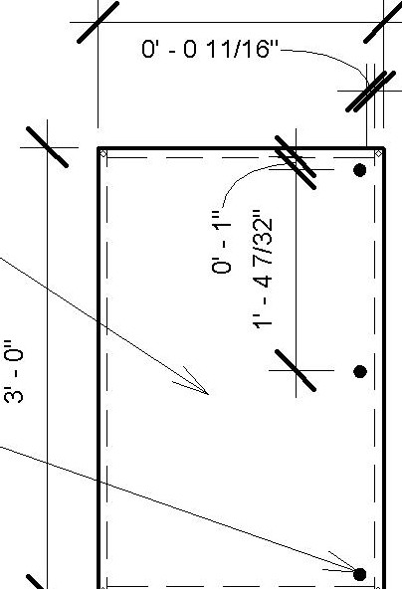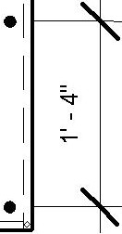_J

SHOWN IS AN ENLARGED DEPICTION ON THE ONE INCH DIAMETER HOLE (VOID EXTRUSION) IN THE TOP PANEL FOR THE CONNECTION OF THE SENSORY WALL PIECE.

HOLES PLACED EQUAL DISTANCE FROM EACH OTHER WITHIN THE FACE OF THE TOP PANEL ALONG BACK EDGE.
I
L_ I

I

BACK PANEL

b

•NOT SHOWN IN TOP PANEL HERE ARE THE THREE HOLES FOR SENSORY WALL ATTACHMENT.

TOP PANEL
FRONT PANEL

CLIENT DATE
UNIVERSITY

INTERIOR DESIGN IDES 424
FALL 2020 THERAPLAY

SCALE: 1/2" = 1'-0"

SHEET: A102

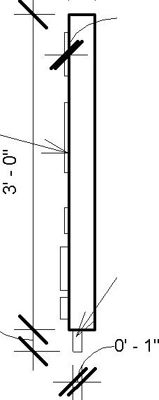
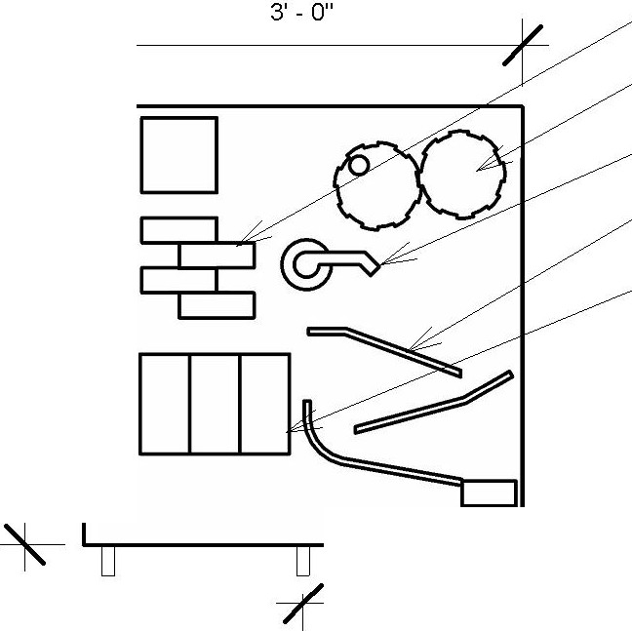
PIECE C: SENSORY WALL PIECE
SENSORY WALL ELEMENTS; i.e. TEXTURED FABRICS/MATERIALS, FINE MOTOR SKILL ACTIVITIES, DOOR KNOBS, SWITCHES, ETC. | O' - 3"  ff- | O' -0 112"  DOWEL PEG TO INSERT INTO TOP OF PLATFORM PIECE, PIECE B. |  |  |  | BRICK TEXTURE MATERIAL
 |  |  |  |  |  | MANUALLY TURNING COG WHEELS |  | THERAPLAY FURNITURE
 |  |  |  |  |  | DOOR KNOB |  | PIECE PROJECT
 |  |  |  |  |  | RAMPS FOR BALL TO ROLL DOWN |  | CARMEL, IN
 |  |  |  | b |  | DIFFERENT MATERIALS SENSORY WALLS |  | DESIGNING FURNITURE
 |  |  |  |  |  | •ALL MATERIALS PLACED ON 1/2 INCH THICK WOOD BOARDS TO PERTRUDE FROM THE BACKING. |  | FOR OCCUPATIONAL AND PHYSICAL THERAPY PURPOSES
 |  |  |  |  | 1' - 4"
SIDE VIEW |  |  | 2 | FRONT VIEW
DETAILED PLATFORM NOTES:
NOTE:
PEGS ARE 1 INCH DIAMETER BY 2.5 INCHES LONG SCREWED INTO THE BOTTOM OF THE SENSORY WALL. THEY ARE EVENLY SPACED 16 INCHES O.C.

SENSORY WALL ELEMENTS ARE APPLIED TO THE SENSORY WALL VIA RUBBER CEMENT GLUE OR SCREWS.
 |  |  |  |  |  |  |  | BALL STATE
 |  |  |  |  |  |  |  | UNIVERSITY
 |  |  |  |  |  |  |  | BALL STATE UNIVERSITY
 |  |  |  |  |  |  |  | IMMERSIVE LEARNING
 |  |  |  |  |  |  |  | PROGRAM
 |  |  |  |  |  |  |  | DRAWN BY |  | KELSEY PARK
 |  |  |  |  |  |  |  | COMPANY |  | BALL STATE UNIVERSITY
INTERIOR DESIGN IDES 424
FALL 2020
 |  |  |  |  |  |  |  | CLIENT |  | THERAPLAY
 |  |  |  |  |  |  |  | DATE
 |  |  |  |  |  |  |  | SCALE: 112" = 1'-0"
 |  |  |  |  |  |  |  | SHEET: A103

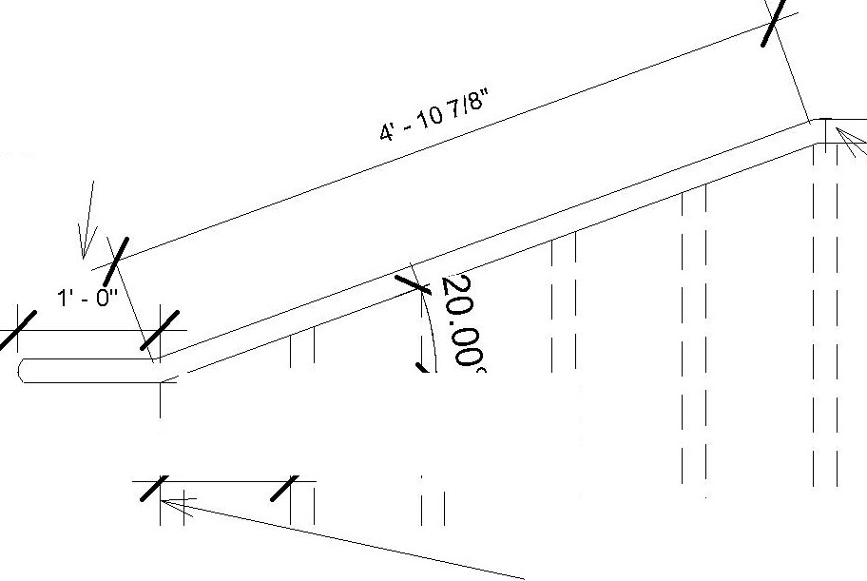
PIECE D: HAND RAIL PIECE
,t/ // | ANGCCD COR CON,CC.,ON rn RA,UNG |  | 12 INCH EXTENSION FROM END OF RAILING REQUIRED BY ADA.  1--IT- I  I I I I | LEGS CONNECTED TO RAILING WITH A SCREW PENETRATING BOTH.  I I  I I  11  I I  I I I I  ALL PEGS ARE PLACED 11 INCHES APART FRONT OF PEG TO FRONT OF PEG.
 |  |  |  |  |  | THERAPLAY FURNITURE
 |  |  |  |  |  | PIECE PROJECT
 | 2 INCH X 2 INCH WOOD PEG.  29.5 INCHES TO HIGHEST POINT. |  |  |  |  | CARMEL, IN
"' | 1 INCH DIAMETER DOWELS TO CONNECT TO PIECE A, STAIR PIECE. |  |  |  |  | DESIGNING FURNITURE FOR OCCUPATIONAL AND PHYSICAL THERAPY PURPOSES
11
O' - 2"
#
RAIL LEG - SIDE VIEW |  | 2 RAILING - SIDE VIEW
DETAILED HANDRAIL NOTES:
NOTE:
RAILING LEGS ARE 2 INCH X 2 INCH (SQUARED).
THE 1 INCH DIAMETER ROUND DOWELS EXTENDING OUT OF THE RAILING LEGS ARE TO CONNECT INTO THE STAIR PIECE.
THE TALLEST POINT OF THE RAILING LEG REACHS 2 FEET 5 1/2 INCHES, WHICH IS THEN CUT DOWN AT A 20 DEGREE ANGLE FOR THE HAND RAIL TO REST UPON.

THE LENGTH OF THE ANGLED HAND RAIL IS 4 FEET 10 7/8 INCH, W ITH 1 FOOT HORIZONTAL EXTENSIONS AT EITHER END.
THE LEGS ARE CONNECTEDTO THE RAILING WITH A SCREW PENETRATING THROUGH THE RAIL INTO THE LEG, SHOWN IN FIGURE 104-2.
 |  |  |  |  |  | BALL STATE
 |  |  |  |  |  | UNIVERSITY
 |  |  |  |  |  | BALL STATE UNIVERSITY
 |  |  |  |  |  | IMMERSIVE LEARNING
 |  |  |  |  |  | PROGRAM
 |  |  |  |  |  | DRAWN BY |  | KELSEY PARK
 |  |  |  |  |  | COMPANY |  | BALL STATE UNIVERSITY
INTERIOR DESIGN IDES 424
FALL 2020
 |  |  |  |  |  | CLIENT |  | THERAPLAY
 |  |  |  |  |  | DATE
 |  |  |  |  |  | SCALE: 1/2" = 1'-0"
 |  |  |  |  |  | SHEET: A103

