Ross Community Center

Immersive Learning Study

Visualizing Ethnographic Voices

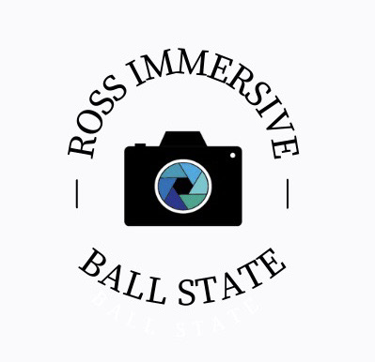

Muncie, Indiana
September 7 Tuesday / September 16 Thursday
5:30-7:30 pm

V 1.4

WELCOME LETTER

Dear Participant,
Thank you for signing up to participate in the “Visualizing the Ethnographic Voices of Community Revitalization” immersive learning class. You have been invited to participate by the important members of your community.
Thank you for volunteering your time and participating in this project. We believe you are making an important impact by teaching others about your identity, community, and the people around you. The purpose of “Visualizing the Ethnographic Voices of Community Revitalization” in Muncie, Indiana, is to learn about the culture you are in, and who you are through the use of photography and your stories.
The SBMS concept was developed from a participatory model called photovoice, after Dr. Tait noticed that the local community’s voice is often missing in various sociological and communication circles. Thus, SBMS has an origin from (Mark 8: 22-25) and seeks to learn beyond the obvious. It is our desire that through you and this class assignment, outsiders will have their “eyes opened” and learn about you and your respective community in a new way.
We believe that in addition to teaching others, this will be an exciting learning experience for you. The “Visualizing the Ethnographic Voices of Community Revitalization” team is excited about this class and hopes you will be too.

Cheers,

Gabriel B. Tait, PhD
Associate Professor (Faculty Mentor)
Ball State University
Department of Journalism
Art & Journalism Building, 334
Muncie, Indiana 47306
(765) 285-8222
Email: gbtait@bsu.edu

BIOGRAPHIES OF THE STUDENT IMMERSIVE LEARNING TEAM

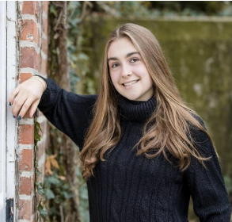
Katelynn Bilka is a Freshman at Ball State University pursuing a Bachelor of Science in Public Relations. Previously in her high school career, she was involved in many extracurriculars, and held many noteworthy positions and was recognized and awarded for her academic and community work. Some of these organizations included theater, newspaper (Editor in Chief), class council (Secretary), and varsity girls' soccer (JV Captain). She also upheld a 4.0+ GPA since freshman year and graduated fourth in her class with a GPA of 4.375.
In this class, Katelynn would like to take on a role involving work with the social media profiles, whether that be conducting Instagram lives, posting to our stories, editing photos/posts before they’re published, or drafting professional emails when necessary. Because of her major, concentration in Media Design, and her (hopeful) role as DeHority Residence Hall Council PR chair, she believes that she will be good at using her extrovert like personality, experience in PR, and professionalism to help the team work towards its necessary quotas and goals. Because of her networking abilities and involvement in various organizations, Katelynn also will be able to use these connections to the team’s advantage.

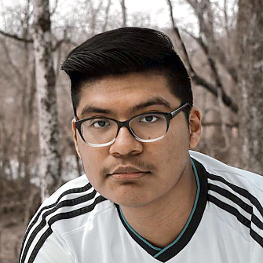
​​Emmanuel Flores-Cruz is a second-year underclassmen at Ball State University. He is currently double majoring in Journalism and Telecommunications with a minor in Spanish. He transferred from Ivy Tech Community College via the ASAP Program, which allowed Crus to obtain his associate degree in under a year before transferring. Since middle school, he has worked with video editing, and has developed a passion for media communications. His experience expands through recording video, interviewing, working inside a studio, and other types of media related projects.

In this class, Emmanuel is hoping to do something related with video, but is comfortable with utilizing some type of equipment or media. With around eight years of experience, he is hopeful he can use his skills or possibly even teach others what he’s learned over the years. He is comfortable being on camera and would love to take on interviews with the community sponsors.

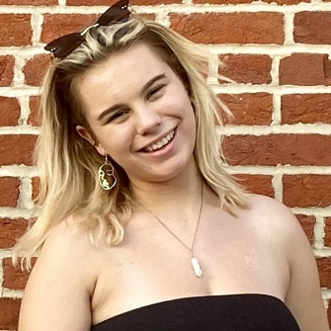
Seattle Greenwell is a Freshman at Ball State University double majoring in Theater Creation, and Advertising. She is an active member of the Honors College and plans to get involved in a series of clubs this coming semester. Seattle is more than excited to be participating in the Ross Immersive project and would like to thank the university for providing her with this once in a lifetime opportunity.

She believes this project will provide better insight into the definition of community and revitalization. She would like to invite the audience to absorb the media presented with an open heart and mind as she and her peers show what the community in Southern Muncie can provide.

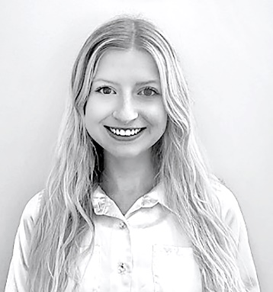
Sarah Hale is a Junior Advertising student with concentrations in Emerging Media and a minor in Fashion. In her time at Ball State University, she has gained skills in digital design and advertising. Through a local partnership with a small business, she developed skills in analytics and digital marketing. She hopes to gain valuable interpersonal and visual research skills through this immersive learning experience. In addition, she hopes to increase her skills in growing and maintaining social network accounts. In the future, she hopes to work in social media management or account management in the fashion advertising industry.

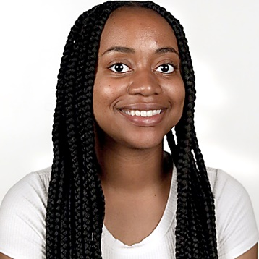
Sumayyah Muhammad is a junior majoring in Magazine Media Journalism at Ball State University. She is from Bloomington, IL and wrote for her high school’s newspaper for one year. Sumayyah is currently the Lifestyles Editor of The Ball State Daily News. As an editor, Sumayyah knows how to interview people as sources for whatever she is writing. In the future, Sumayyah intends to either write for a newspaper/magazine publication or start her own blog to report on media content that gives meaning to community.

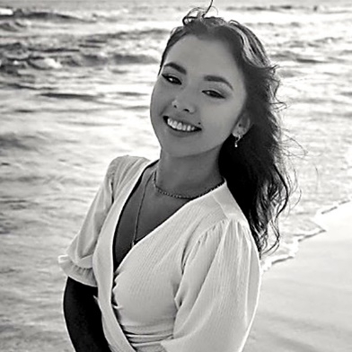
Teagan O’Meara is a Freshman majoring in Journalism and minoring in Marketing. She is from Brownsburg, IN, and attended Brownsburg High School, where she was involved in theatre and show choir. While in high school, she also gained the opportunity to intern for a wedding venue. Her responsibilities consisted of posting to social media accounts, coordinating events, working as event staff, and more. She gained much knowledge involving marketing strategies, the ins and outs of running a business, and how to interact with different types of people. Teagan spent most of her time attending sales training, venue coordinator meetings, marketing meetings, and client-coordinator meetings.

In this class, Teagan is hoping she can gain more experience on the promotional side of things. She wants to become more comfortable talking to groups of people as well as one-on-one professional interactions. Thinking quickly and creatively is not one of Teagan’s strengths, but this class will hopefully help that. As far as social media goes, Teagan wants to become more knowledgeable on tips and tricks when posting to promote. Because of her internship, Teagan has gained some insight on tools and things to remember when posting for a company, and she thinks this class will broaden her horizons.

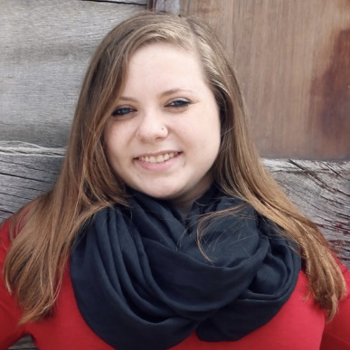
Cierra West is from the southside of Muncie Indiana, where she works as a manager at Fazoli’s. Cierra graduated for Muncie Central High School in 2017. After taking a year off, she is backat Ball State University as a Junior studying to get a Bachelor of Science. Her main field of study is Journalism with a concentration in Mass Communication. While she was in Florida, she worked on a school paper in Sanford, Florida for Seminole State. Currently, she is focused on personal relations and advertising, while hoping to do something better in the community at the Ross Center.
Mikkenzi Edwards is an undergraduate student in her sophomore year at Ball State University. Her degree she is pursuing is a Bachelor of Science in Public Relations with a concentration in Emerging Media and Photojournalism. She is heavily involved with Ball States University Singers (the Goodwill Ambassadors of Indiana). Not only does she participate in the Glee Club but, is also the Media Management Head and Design Chair for the organization. Before this course, Mikkenzi has been active in many different academic diverse elements. She served as one of the main creators for her African American Experience class in high school.
Mikkenzi was responsible for creating an exhibit for her hometown to see the cultural history that has been shut behind closed doors for too long. To complete her responsibility, she had to dive into the community to find the ones who had the key. This class created the burning passion of her future career! In this course, specifically, Mikkenzi is beyond excited to become involved with the creative roles within the project, itself. She would love to help assist in the photography aspect of things. She believes that photography serves as a close look into another one’s eyes. It is not only a mere image, but there is always a deeper meaning behind the captured photograph. She hopes to bring her prior experience and knowledge of public relations and creative design to the table to assist in this life-changing project.
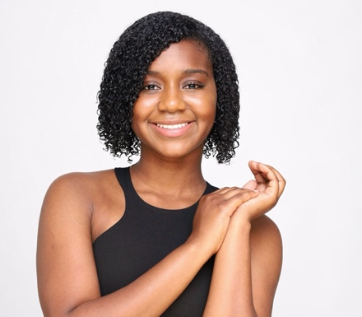
Rhoni Paige is a junior at Ball State University. Her major is Journalism with a concentration in News alongside with a theatre minor. Before attending Ball State University, Rhoni was a student at Alabama State University for two years. Within her two years, she served as a member of the campaign team for Miss Alabama State University, a member of the ASU Dance Company, and a member of the National Association of Black Journalists. As a member of the Miss Alabama State University campaign team, she was responsible for communicating with and persuading people to vote. Along with being the organization’s meeting facilitator, she was also responsible for running all the social media accounts. As a member of the ASU Dance company, she was responsible for hosting and conducting practices. Lastly, as a member of The National Association of Black Journalists, she was responsible for keeping up with the daily news, writing news stories, and attending meetings. As a student at Ball State, Rhoni is a member of the Honors College and a new member of Alpha Kappa Alpha Sorority, Inc. She serves as the chairman for all the sisterly activities, and a chairman of the arts for the sorority. In this class, Rhoni is looking forward to working with the Muncie community. She wants to bring her leadership skills, interactive skills, and knowledge to make this project great. She wants to work with the content team to help run the social media accounts and editing. She is a people person so working with the training team to conduct interviews would be ideal. Rhoni is looking forward to the semester in this immersive course.

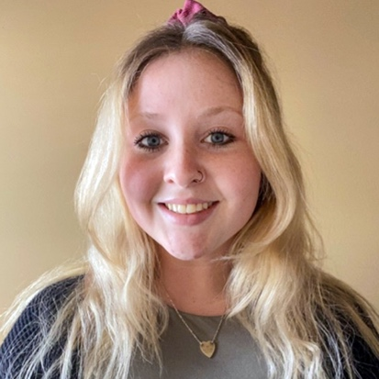
Madison Goodnight In high school I was given the opportunity to give interviews, work with the community and more at our student-ran radio station. This allowed me to gain a professional broadcasting voice, script writing skills and editing. Also, it has given me the chance to set up/run websites, social medias and events. Also, throughout my first two year of college I gained tons of interview experience. I see this as allowing our group to have someone with the experience and growing knowledge to handle interviews and editing skills.

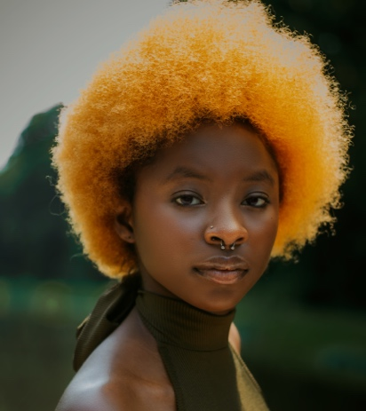
Divine Ngangu is an undergraduate at Ball state university majoring in Public Relations with minors in Peace studies and conflict resolution, international studies, and French. Divine is currently an intern at Ball State’s peace and conflict center, where she utilizes her skills to promote/coordinate events, research, and maintain the center’s social media presence. She is also an active member of both the African Student Association and Public Relations student society of America; in both organizations she holds executive roles. In ASA she is the secretary and in PRSSA she is in charge of members relations. Considering her skillset, Divine would prefer the role that involves public relations and social media.

BIOGRAPHY OF THE FACULTY MENTOR

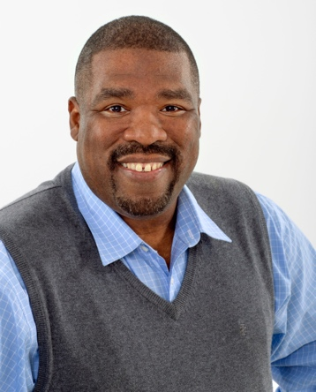
Dr. Gabriel B. Tait of Pittsburgh, Pennsylvania, is spending his life transforming how people look at the world.
Dr. Tait’s research focuses on the impact of photography in cross-cultural context. His studies seek to explore and understand how photography is used in constructing and representing cultural identities and the way people see the world. Specifically, he is looking at the peoples and cultures in three U.S. cities (Pittsburgh, PA, Indianapolis, IN, and Jonesboro, AR), and how the study of visual representation shapes one’s identity. He earned his Ph.D. and M.A. in Intercultural Studies at Asbury Theological Seminary (Wilmore, KY) and a B.A. in Communication with emphasis on photojournalism at Slippery Rock University of Pennsylvania (Slippery Rock, PA).
Prior to attending seminary, he served 25 years as a national and international newspaper photojournalist covering events in Iraq, Kosovo, Egypt, and numerous other countries for several of the country’s top newspapers, primarily the Detroit Free Press and the St. Louis Post-Dispatch. “Transformation of the blind to see (i.e., Sight Beyond My Sight) is what ministry and communication is all about,” says Dr. Tait.
Currently Dr. Tait is an Associate Professor of Journalism (Diversity and Media) at Ball State University in Muncie, Indiana. Dr. Tait and his wife Erica have two sons, a daughter, and a rescue dog named Boots.

BIOGRAPHY OF OUR COMMUNITY PARTNER

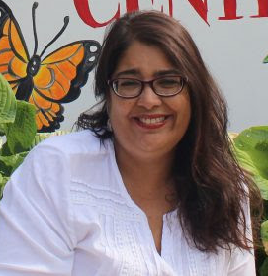
Jacqueline Hanoman is a Venezuelan-Guyanese sociologist, educator, qualitative researcher, and nonprofit leader. She is the Executive Director of the Ross Community Center and has over 25 years of experience successfully developing multidimensional poverty programs and projects with NGOs, universities, multilateral and international organizations, governments and nonprofit organizations in Venezuela, South Africa and the USA. As a lifelong learner and qualitative researcher, she is passionate about working with people in marginalized communities and walking hand in hand with them to create integrated approaches, focused on strengthening democratic values, equity, and supporting people and organizations to confront challenges of social injustice (including economic and racial), insecurity and public health. Her areas of research are constantly evolving within these areas of multidimensional poverty. Her most recent research areas of focus have been food insecurity, as related to public health and socioeconomic and cultural inequities.

GOALS OF CLASS

There will be four objectives for this immersive learning partnership:

- To use photography and the photographs collected from the Ross Immersive partnership as a way for community participants to express to outsiders how they understand change in their community and the meanings they give to these categories.

- To encourage community participants to reflect on their personal and community concerns through photography.

- To foster a dialog and gain knowledge about personal and community issues through individual and group discussions among participants about photographs.

- To gain a clearer picture (both literally and figuratively) of the way community participants, in their different experiences and contexts, make sense of the world in which they live, and to educate outsiders about these experiences and context.

THEME OF CLASS and PARTNERSHIP

In this Ross immersive learning class, students will build an advanced understanding of diversity, develop their interviewing and photography skills, and contribute to an ongoing community revitalization project. As part of the relationship, students will partner with staff and members of the Ross Community Center, and by extension, the Thomas Park/Avondale community in Muncie, to develop visual ethnographies, documenting community issues, opportunities, and goals that contribute to community revitalization. The theme of revitalization will be explored during this class.

ELEMENTS OF A ROSS IMMERSIVE PROJECT

1. Photographs: participants take photographs that mean something to them, regarding specific project topic outlined.
2. Narratives: after discussing the photos, the photographer will review their notes and writes descriptions for each picture, using the showed method. This narrative helps the image, the participant, and the SBMS understand the meaning that is being communicated.

LEARNING ABOUT IDENTITY FROM THOSE WITHIN

*Guiding questions:

1. What can we learn about participant’s identity and culture through the use of photography?

2. In what ways do the participants visually represent themselves and what do these visual representations say about their community?

3. What stories do the participants share about their community?

*The Big Questions:

- What is most important for outsiders to know about your community?

- How do you remember your community?

- How has your community changed / stayed the same?

INTRODUCTION TO PHOTOGRAPHY

In this introduction to photography section, we will look at three important questions:
- What is photography?
Photography is the art or practice of taking and processing photographs.
- What is a photograph?
A photograph is a picture made using a camera, in which an image is focused onto film or other light-sensitive material and then made visible and permanent by chemical treatment or stored digitally.
- Why is photography being used in this study?
Current studies reveal the importance of photography as a teaching tool, youth excitement about taking photographs, and photography being a useful tool to learn meanings from participants about their photographs.

Have a group discussion about photographs:
- Find out the photographs and people’s likes and dislikes
- Find out what participants’ previous experience of photography may be

Help participants:
- Identify different parts of the camera
- Understand the functions of different parts of the camera
- Understand the basics of photographic theory
- Load and unload the camera battery and digital flash card
- Charge batteries
- Hold the camera correctly
- Understand how to care for the camera properly
- Protect the camera using the appropriate camera bag, lens cover, etc.

ETHICAL CONSIDERATIONS

The concept of a Ross Immersive project is simple and may seem harmless, but there are several ethical considerations that need to be addressed prior to and during the project.
*Is it ethical?
1. ASK YOURSELF: Is it invading someone’s privacy?
Consent Needed | Consent NOT Needed
•Taking a picture of someone who is recognizable (faces, tattoos, or markings)  •Taking a minor’s picture (under 18 years)  •Taking a picture of personal belongings and/or personal property | •Taking a picture of public figures  •Taking a picture of the environment or public settings  •Taking a picture of people who cannot be specifically identified

2. Protect Participants: participants must refrain from entering dangerous spaces/situations to complete the project. Think not only about danger in terms of physical harm, but also in emotional harm, harm to individual reputation, or potential financial harm, among others. ASK YOURSELF: Will it harm me or others? Is it dangerous?
3. Protect the Community: it is important to protect others by abstaining from taking pictures that may harm the reputation, safety, or individual liberty-of another. ASK YOURSELF: Will it put a person’s employment, status in the community, etc. in jeopardy?
4. False Light: it is necessary to make sure that situations in the community are reflected accurately. Necessary steps must be taken to accurately portray the community and to avoid taking photographs of images that could be taken out of context. ASK YOURSELF: Is it truthful? Does it accurately represent the situation?
How do I approach subjects?
When taking a picture of a human subject or their personal property you must ask their permission first. Make sure that the images you take will accurately represent the situation. There are three steps to consider:
- Assess: Can you approach them safely or are they engaged in a dangerous activity?
- Explain: Explain the project and your involvement.
- Ask for Consent: Ask, “would it be acceptable to use images from them to discuss the themes of your project in a group setting?”

PARTICIPANT SESSION I
  - Introduction (Approx. 1 1/2 hours)

Goal: Participants will understand the purpose and the process of the project.

- Introduce yourself and welcome participants; take care of housekeeping issues: bathrooms, sign-in sheets or other paperwork, etc.
- Conduct an icebreaker exercise to help participants get to know each other and get comfortable.
- Introduce participants to the project.
a. Discuss the project's purpose, who is sponsoring it and how it will be used.
b. Frame the topic.
c. Explain that participants will explore this topic by taking pictures in their community and talking about their pictures.
d. Go over the SBMS process; preview what will happen at each meeting.
- SBMS Practice Activity

PARTICIPANT SESSION II
  - Picture Taking Tutorial - (Approx. 1 1/2 hours)

- Discuss camera ethics
a) When would you not want to have your picture taken? How do you feel when you are photographed at a time when you don't want to be? How would you feel if a stranger was taking your picture? How do you think other people feel? How can you make them feel most comfortable?
b) Asking permission
i) When to ask - if you can tell who the person is, you need permission
ii) Practice how to ask
iii) If applicable, discuss the need for written permission to use the photos.

*Discuss how to use the consent forms.

- Take group and individual photos of participants.
- Get photo consents signed by all participants. (Good opportunity for participants to practice asking each other for permission and using the forms.)

- Discuss safety issues.
- Don't photograph people who don't want to be photographed.
- Don't photograph illegal activities.
- What to do if someone becomes angry that you took their picture.

**** Role Play****
- Discuss what makes a good picture. Have some samples that help to discuss/illustrate these concepts:
- Get close enough to show any important details.
- Can hold camera horizontally or vertically.
- Hold camera still and level; be careful not to move the camera when you take the picture.
- If the photo is important to you, take several (different) shots.
- Q&A

- Distribute cameras (if applicable) & discuss how to use them
a) Go over the mechanics of how the camera works.
b) Focus, flash, zoom (if applicable).
c) If digitals are available, practice with them.

- Go over logistics of picture taking
- When, where, individual or in groups, when/where to return film/cameras for developing, identify with name.

- Review SBMS theme a) Discuss what types of pictures might relate to this theme
- Remind participants that they will need to be able to explain what the picture is of and how it is related to the theme

- Be sure everyone understands
a) What they are supposed to do next (take/turn in camera/film/pictures)
b) When/where the next meeting will take place
c) That they will see/discuss their pictures at this meeting

  - USAGE AND CONSENT FOR THE PUBLICATION OF PHOTOGRAPHS

I, __________________, agree to participate in the research of Dr. Gabriel B. Tait. I also consent that I will take photographs for the Ross Immersive research study. I agree to participate in both an individual interview and group discussions about photographs produced in the study. I agree that Ross Immersive/SBMS maintains all rights thereof, to reproduce photographs taken by _________________________. I agree that Ross Immersive/SBMS has my permission to use audiotape and video recording equipment for group and individual conversations during this research process. I, ___________________, acknowledge that the research materials may appear in printed or electronic form and may be available to an international audience for the purpose of furthering the study’s mission. I authorize Dr. Gabriel B. Tait the use and/or reproduction of photograph(s) without acknowledgement and without entitlement to payment. Ross Immersive/SBMS and/or its assignees will retain the copyright ownership of the photograph(s). I understand and agree that if I wish to withdraw from this study, it will be my responsibility to inform Ross Immersive/SBMS coordinator.

Dr. Gabriel B. Tait
ATTN: Sight Beyond My Sight
Art & Journalism 334
Ball State University
Muncie, IN 47304
* * * * * * * * * * *

Today’s Date: ____________________ Signature: ____________________________________
Printed name of participant: ______________________________________________________
Contact telephone number: _______________________________________________________
Physical address: _______________________________________________________________
Community Organization Directors Name and Telephone #______________________________ ______________________________________________________________________________

PHOTOGRAPHY ETHICS

Ethics is considered a standard of beliefs, morals and reasoning that people maintain to preserve the integrity and dignity of their research and respective participants. Photography ethics is a set of principles that guide photographers in the way that they take photographs. This process aids participants in developing appropriate responses to issues of crisis and in governing themselves accordingly.
As participants in this Ross Immersive there are several ethical considerations you must be aware of and remember:
1. As Ross Immersive photographers we will honor all posted signs around government buildings
2. As Ross Immersive photographers we will seek to understand the culture and gain the subjects’ consent before taking photographs. This includes gathering detailed information for photograph captions
3. As Ross Immersive photographers we will appreciate the privilege of being a part of the community we are photographing
4. As Ross Immersive photographers we understand we are not paparazzi (showoffs). Neither the Ross Immersive researcher nor we as Ross Immersive photographers will exploit our photographs of subjects
5. As Ross Immersive photographers we will not manipulate or alter our photographs
6. As Ross Immersive photographers we will not misrepresent this study or ourselves
7. As Ross Immersive photographers we will return all items used during this study
*Special note: From the researcher’s perspective, I believe it is of special importance to acknowledge:
1) Participants have the right to discontinue the study for medical or other unforeseen circumstances (all equipment must be returned in the same condition received).
2) Participants have the right to remove photos as specified in the methods section (see method section).
3) Participants will be provided copies of the photographs, if requested.
4) The photographs will be used, including but not limited to: the researcher’s books, journals, newspaper publications, websites, training seminars, and photo exhibits.

__________________________ _______________________
Ross Immersive Participant Date

