Indianapolis International Airport
Boarding Process

Matt Smith
7800 Col. H. Weir Cook Memorial Dr, Indianapolis, IN 46241
(317)-487-9594

Renegade Technology
Zachary Siddiq, Project Manager
Colin Kerrigan, Communications Specialist
Adam Rivera, Business Analyst
Evan Russomanno, Information Security Analyst
Cooper Smolek, Analytics Specialist

4/2/2021

Table of Contents

Table of Contents ii
Table of Figures v
Introduction 1
Problem Statement 3
Scope Statement 4
Feasibility Analysis 6
Net Present Value 7
Information Gathering 9
Meetings with the Client 9
Other Meetings 10
Online Methods 11
Airport Documentation 11
Statement of Current Operations 12
As-Is Business Process Model 12
To-Be Business Process Model 17
Statement of System Requirements 20
Success Criteria 21
Alternate Solutions 22
Heat Map 22
Touchless Kiosks 22
Boarding Notifications 23
Grab-and-Go 23
Do-Nothing 23
Evaluation of Alternatives 24
Cost-Efficient – 5 25
User-Friendly – 7 26
Low Maintenance – 4 27
Consumer Confidence – 9 28
Safety – 10 29
Other Considerations 32
Proposed System 34
Symptoms of the Problem 34
Implementation Plan 36
Construction Plan 37
Installation Plan 40
Training Plan 41
Conversion Plan 42
Maintenance Plan 43
Hardware 43
Software 44
Security 44
Backup and Disaster Recovery 45
This includes the system backup to maintain data integrity. 45
Post-Implementation Review 46
Review of Success Criteria 46
Trigger 47
Exit Strategy 48
APPENDIX A: Root Cause Analysis Diagram 49
APPENDIX B: Boarding As-Is Business Process Diagram 63
APPENDIX C: To-Be Business Process Map 69
APPENDIX D: Staffing Plan 73
APPENDIX E: TEAM STANDARDS 79
Communication 81
Equal Understanding 81
Decision-Making 83
Accountability 83
Access to Information 83
Trust and Respect 84
Professionalism 84
Attendance and Punctuality 84
Quality of Work 84
Consequences for Violating a Standard 85
Rewards for Following All Norms 85
APPENDIX F: Supplemental Industry Analysis 86
APPENDIX G: Meeting Notes 111

Table of Figures
Figure 1: Root Cause Analysis Diagram 3
Figure 2: Maximum Feasible Cost Formula 8
Figure 3: As-Is Business Process Map 12
Figure 4: To-Be Business Process Map 17
Figure 5: Multiple Criterion Decision Analysis Matrix 31
Figure 6: Solution Diagram 32
Figure 7: Mobile Application Wireframe 36
Figure 8: Administration Panel Wireframe 37
Figure 9: Systems Map 41
Figure 10: Root Cause Analysis (Large) 50
Figure 11: Root Cause Analysis Part 1 51
Figure 12: Root Cause Analysis Part 2 52
Figure 13: Root Cause Analysis Part 3 53
Figure 14: Root Cause Analysis Part 4 55
Figure 15: Root Cause Analysis Part 5 57
Figure 16: Root Cause Analysis Part 6 58
Figure 17: Root Cause Analysis Part 7 60
Figure 18: Root Cause Analysis Part 8 61
Figure 19: As-Is Business Process (Large) 64
Figure 20: As-Is Business Process Part 1 66
Figure 21: As-Is Business Process Part 2 68
Figure 22: To-Be Business Process (Large) 69
Figure 23: To-Be Process Map (Large) 70
Figure 24:To-Be Process Map (Part 1) 71
Figure 25: To-Be Process Map (Part 2) 72

Introduction
The Indianapolis International Airport is a highly ranked and respected airport located in Indianapolis, IN. In 2019 the Indianapolis Airport served approximately 9.5 million passengers throughout the year. The Indianapolis Airport is also a major hub for cargo and cargo planes, as they are the second-largest FedEx hub in the world. FedEx Express accounts for 55% of the total flight share coming out of the airport. They are the sixth busiest airport in terms of air cargo. The Indianapolis Airport employs 10,000+ people to make sure that each customer has a smooth experience from the time they drive up, to the second they step onto the plane.
The boarding process starts at the end of security and ends with the first step on the plane. This includes ticket gates, shops, concessions, ATMs, restrooms, charging stations, and vending machines. The concessions and shops produce a significant amount of revenue. In 2019, the airport made $12 million in revenue from two Starbucks locations alone. Many of these concessions and shops provide well-needed food, supplies, and souvenirs to visitors from all around the globe. In 2018, a task force was created for a ‘concessions refresh’ program. About forty-six of fifty-four total concession licenses began to expire in 2018. This led to the task force assisting preexisting concessions to resubmit licenses to stay, as well as sending proposals to potential new vendors. It was a massive undertaking to keep as many concessions and shops open as possible.
In early 2020, with the advent of COVID-19, most major industries in the United States were financially hit in some fashion. Airports and the aviation industry have seen a loss in consumer demand for flights. In April 2020, the Indianapolis Airport served less than 300 customers a day due to a fear of traveling. To put this into perspective, parking services used to average about $260,000 a day in revenue. As of April 2020, the Indianapolis Airport averaged around $15,000-$20,000 a day. Many concessions had to close due to a lack of customers and profit. As of December 2020, only 60% of their concessions are reopened and many fear not meeting the minimum annual guarantee needed to stay open.
The Indianapolis Airport has created a COVID Task Force to discuss ways to keep the airport safe for both customers and employees. The task force also works to find ways to encourage customers to wear masks, social distance, and take safety precautions. The airport began strongly recommending facemasks in June 2020 but does not currently enforce compliance. The Indianapolis Airport has a minimum of twelve employees at any given time sanitizing seats, tables, and other high-contact areas. Also, the Indianapolis Airport has HEPA filters installed throughout the airport to keep the air clean.
With news of a vaccine potentially becoming available as soon as December 2020, the airport will most likely see an influx of new and returning travelers. While it may be years before numbers return to pre-COVID marks, the number of customers will continue to grow over time. Many will come to expect the same amenities they had before the pandemic hit the United States. Also, a plethora of new health standards must be implemented to combat current and future viruses in a post-COVID world.

Problem Statement
The problem is that the Indianapolis Airport must provide customer service without sacrificing a healthy environment in the boarding process. While it will take time for Indianapolis Airport’s consumer confidence levels to recover, the new expectations customers will have in a world negatively impacted by COVID-19 will create business challenges that must be solved. Passengers will expect a clean environment that allows for social distancing when traveling through the facility.
Due to financial challenges, the Indianapolis Airport is looking to find cost-efficient solutions. Adding marketing through signage will not be enough, as passengers ignore it as they travel through the Indianapolis Airport. The solution to this problem needs to be financially conscious and considerate of how passengers proceed through the Indianapolis Airport. The root cause analysis diagram is shown in Figure 1 (Root Cause Analysis Diagram), which was developed through various meetings with the Indianapolis Airport to determine their main issues. A full-size Root Cause Analysis diagram can be found in Appendix A.
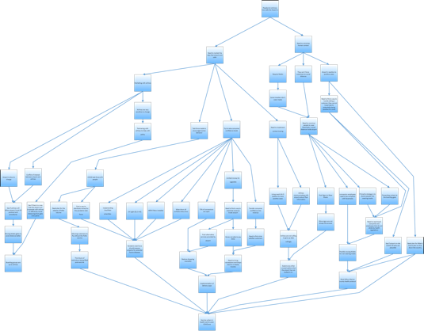

Figure 1: Root Cause Analysis Diagram

Scope Statement
The scope statement will provide an overview of the quality, cost, and time of any work being done for the Indianapolis Airport. These topics are meant to outline the work needed for the final deliverable.

Quality
The quality guidelines are critical business metrics that will be included in the final deliverable.
- This report will include a problem statement that states the airport’s issues in an easily comprehensible way
- The feasibility analysis will be provided to estimate the boundaries of the report
- Information gathering itemizes a collection of methods used to gather necessary information for the project
- The root cause analysis diagram is supplied to determine the source of the problem
- The As-Is and To-Be process maps demonstrate a flow of current and future operations in the boarding process
- The industry analysis is a collection of research done relevant to solving the Indianapolis Airport’s problem

Time
These time constraints must be met to ensure the timely delivery of the proposed solutions.
- The planning phase will be completed by September 30, 2020
- The analysis phase will be completed by November 24, 2020
- The evaluation of alternatives will be completed by February 15, 2021
- The formal presentation will be by late April
- The solution will be presented by late April
- Bi-weekly status reports with client
- Monthly meetings with the client via Zoom
Cost
The following guidelines provide an overview of various costs to the Indianapolis Airport.
- The Maximum Feasible Cost will be provided to calculate a benchmark number as a representation of the severity of the problem and symptoms.
- The Total Cost of Ownership (TCO) will be provided in the final deliverable at MSRP pricing.
- A proper Return on Investment (ROI) will be calculated.
- These figures will be calculated and provided in the Economic Feasibility.

Feasibility Analysis
The feasibility requirements outline the boundaries for the implemented solution. Each requirement must be met to deliver a relevant solution to the Indianapolis Airport.

Technical Feasibility
These guidelines ensure any technological boundaries fit within the Indianapolis Airport’s requirements.
- The solutions will not include any passenger or airline data due to privacy concerns.
- The solutions cannot involve concession’s POS systems because they are privately operated businesses outside the boarding process.
- The solutions cannot involve any of the airline’s services because the airline does not share ticket and customer information.

Operational Feasibility
These operational boundaries will help narrow down the list of potential solutions to eliminate any incompatible solutions.
- The airport cannot prevent passengers from flying due to noncompliance with COVID regulations because it is a public space.
- The airport cannot dictate airline boarding groups and other airline policies as they have no control over airline operations.
- The airport cannot control how concessions and their employees operate as they are private entities.
- The airport cannot violate federal and state health guidelines.
Economic Feasibility
The economic feasibility will ensure any solution is cost-effective and fits the financial criteria that the Indianapolis Airport requires. The guidelines will allow the Indianapolis Airport to implement the solution within their economic constraints.
Cost/Benefit Analysis
This analysis of various economic constraints outlines which actions the Indianapolis Airport can and cannot take concerning the solution.
- When calculating risk, expect “XYZ” to happen. However, “G” could happen which would disrupt the calculations.
- Indianapolis Airport can expect to pay one price upfront for the proposed solution with no additional costs.
- Any required maintenance of the proposed solution must come from the current budget.

Net Present Value
The Net Present Value analysis of the Indianapolis Airport demonstrates the Maximum Feasible Cost to reach the calculated profit and savings. Figure 2 (Maximum Feasible Cost Formula) represents the maximum amount the client can invest and still gain the stated Return on Investment (ROI).
- $Max. Feasible Cost=\frac{(Savings+Profit-\left(Maintenence \& Ongoing Expenses\right))}{(1+Return on Investment)}$
Figure 2: Maximum Feasible Cost Formula

Assumptions and Sources of Data
The economic feasibility outlines the estimated revenue and expenses to calculate a maximum feasible cost for the solution. A maximum feasible cost is a benchmark number that displays the financial impact of the symptoms of the problem within the boarding process.
- Savings = $4.4 million, which is equal to 80% of a $5.5 million loss from COVID-19
  - Indianapolis Airport lost an estimated $5.5 million in revenue for 2020.
- Profits = $87.6 million , $153.8 million (total operating revenue) -$66.2 million (total operating expenses)
  - Indianapolis Airport’s profit will be an estimated $87.6 million in 2021. This comes from the estimated 2021 budget book.
- Return on Investments = 3%
  - 3% is equal to the average inflation rate of the U.S. dollar.
- Maintenance and Ongoing Expenses= $66.2 million
  - Indianapolis Airport’s 2021 budget book stated total maintenance and ongoing expense cost of $66.2 million.
- $\frac{(\$4,400,000+\$87,600,000\left(-\$66,200,000\right))}{(1+.03)}$ = $25.048 million
- The maximum feasible cost of our solution is approximately $25.048 million

Information Gathering
Information Gathering explains what information was gathered, what was learned from the information, and the method of which it was gathered. The data collected and the methods used aided in gathering necessary information to devise an optimal solution.

Meetings with the Client
Meetings with the Client includes direct communication with the Indianapolis Airport. All of the scheduled meetings were conducted over Zoom and were scheduled with Matt Smith, the Director of IT.
- The first meeting with the Indianapolis Airport held on November 13, 2020, was set up over Zoom to introduce the team, ask initial questions about anything relevant to the boarding process, and gather information for the root cause analysis.
  - Matt Smith, Applications Manager, Dave Shaw, Director of Concessions, Amanda Roy, Concessions Coordinator, Jim Cates, the Project Manager in Product Development, Jason Paltzer, Concessions Post-Security, and Kevin Forbes, Director of Landside Development were present during the meeting.
  - The first meeting lasted approximately two and a half hours. Notes from the first meeting can be found in Appendix G.
- The second meeting with the Indianapolis Airport held on December 4, 2020, was set up over Zoom to share the newly developed root cause analysis diagram, gain a verification of the problem statement, and discuss Indianapolis Airport’s main source of revenue.
  - Matt Smith, Applications Manager, Dave Shaw, Director of Concessions, Jim Cates, the Project Manager in Product Development, and Kevin Forbes, Director of Landside Development were present during the meeting.
  - The second meeting lasted approximately one hour and fifteen minutes. Notes from the second meeting can be found in Appendix G.
- The third meeting with the Indianapolis Airport held on February 17, 2021, was set up to discuss progress made and weight distribution for the solution criteria.
  - The meeting was held with Jim, Jason, Matt, Kevin, and Amanda.
  - Each of the Indianapolis Airport officials selected their weights, which were then averaged out to determine the final weights for each criterion.
  - A broad overview of the heat map solution was described to the Indianapolis Airport and was met with positive reactions and feedback.

Other Meetings
Additional meetings were scheduled with various industry professionals to help gain insight on developing the details of the optimal solution in addition to general advice.
- A Zoom meeting with Active Logic Labs was held on March 4, 2021, which was set up to discuss the development of the app and the software needed to power the heat map. A follow-up meeting was scheduled, and a Scope of Work is expected on March 8, 2021.
  - Don Blackburn, Business Development Manager, and Robert Kehoe, Chief Executive Officer, were present during the meeting.
  - Active Logic Labs is a software development company, based out of Leawood, Kansas.
- A Zoom meeting with Joey Rivera was held on March 5, 2021, which was set up to discuss the technical aspects of the solution.
  - Joey Rivera is the Chief Executive Officer of Eagle6, a cybersecurity firm, based out of Jeffersonville, Indiana.

Online Methods
Web-based forms of information gathering were used to gain further information about the airport and airline industry
- A variety of online sources relevant to the airport and airline industry were used to come to a better understanding of the Indianapolis Airport’s problem.
  - More information about the online sources used can be found in Appendix F.

Airport Documentation
Various internal documentation within the Indianapolis Airport were used to gain information about the budget and financial situation.
- A series of budget and financial reports for the Indianapolis Airport Authority was used to determine the scope of the economic situation.
  - More information about these reports can be found in Appendix F.

Statement of Current Operations

The Statement of Current Operations details the As-Is and To-Be business process maps. The As-Is process map demonstrates how the current boarding process operates at the Indianapolis Airport, whereas the To-Be demonstrates how the boarding process will be more efficient with the proposed solution. A larger version of Figure 3 (As-Is Business Process Map) and Figure 4 (To-Be Business Process Map) can be found in Appendix B and Appendix C.

As-Is Business Process Model
The As-Is process model depicts the current business functions of the boarding process. Each step represents an action or decision a passenger may make while in the boarding concourse.
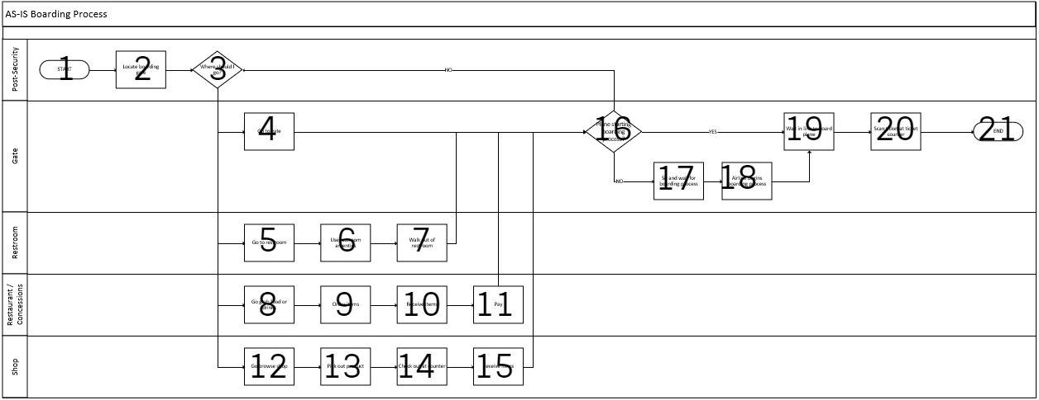
Figure 3: As-Is Business Process Map

- Start As-Is boarding process
  - The boarding process officially begins immediately after security clearance.

- Locate boarding gate
  - Any incoming passengers must first locate their flight gate. The location of the gate depends on what airline a passenger is flying with and their flight destination.
- Decision 1: Where should I go?
- Passengers have options of what they can do before boarding. This would include: waiting at the gate, using the restroom, dining at a restaurant, and shopping at any retail store.
- Go to gate
- While waiting for a flight to arrive, passengers can sit and wait until their ticket is called.
- Go to restroom
- Passengers have the choice to use the restroom facilities if necessary.
- Use restroom amenities
- If passengers go to the restroom, the passenger may choose to use an amenity, wash and dry their hands, or freshen up in the mirror.
- Walk out of the restroom
  - If passengers intend to shop at retail stores, concessions, or dine-in at a restaurant, they must exit the restroom.
- Grab food or drinks
- If a passenger is hungry or thirsty while they wait for their ticket to be called, they have the choice to go to any open dine-in restaurant, concession, or vending machine.

- Order items
- Passenger decides what they would like ordering off of the concession or restaurant menu. This is a human-to-human interaction that requires direct communication with an employee.
- Receive items
- Concession employee transfers ordered product to the possession of the passenger.
- Pay
- The passenger completes the transaction by handing the payment method to the employee directly. The employee then gives back the customer’s card or change.
- Go browse at shops
- Passengers have the option to shop at the various retail locations throughout the concourse. This includes any souvenirs, gifts, or other amenities.
- Pick out product
- Passenger selects the desired product from their store of choice. The passenger physically selects and brings their item to the checkout counter.
- Check out at the counter
- The passenger completes the transaction by paying the employee for the product. This is a human-to-human interaction that requires direct contact between the employee and customer.

- Receive items
- After the passenger purchases the desired product, the customer has the option to continue shopping or return to the boarding gate.
- Decision 2: Plane starting boarding process?
- The passenger has the option to sit and wait for the boarding process, use another amenity within the boarding area, or begin waiting to board the aircraft.
- Sit and wait for the boarding process
- The passenger waits at the boarding gate while the plane arrives until their seat is called.
- Airline begins boarding process
- Once the passenger’s seat number is called, the passenger begins the boarding process by entering the beginning of the line to the ticket counter.
- Wait in line to board the aircraft
- The passenger waits in line to board the aircraft until they reach the ticket counter.
- Scan ticket at the ticket counter
- Airline employee scans passenger’s plane ticket to admit the passenger onto the aircraft.
- End As-Is boarding process
  - The boarding process ends immediately after the passenger steps onto the plane.

To-Be Business Process Model
The To-Be process model describes the future business functions of the boarding process. Each step represents an action or decision a passenger may make while in the boarding concourse.
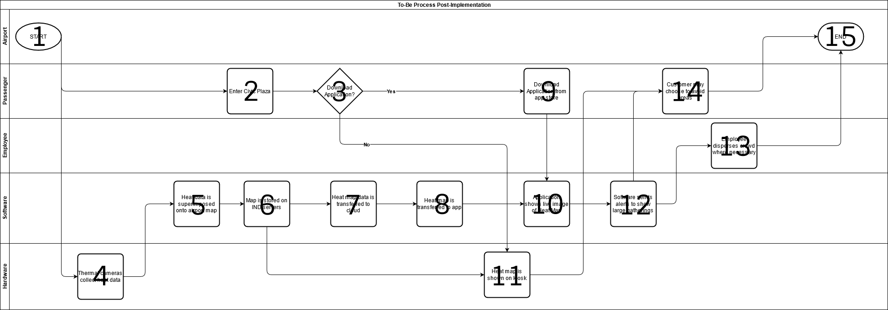
Figure 4: To-Be Business Process Map

- Start To-Be process map
  - The boarding process officially begins immediately after security clearance.
- Enter civic plaza
  - The passenger enters the civic plaza after checking in.
- Download Application?
  - If the customer wants to utilize the heat maps, they will be given the choice of downloading the application or viewing the installed kiosks.
- Thermal cameras collect heat data.
- The installed thermal cameras capture both video input and temperature data for each pixel.
- Heat data is superimposed onto airport map
  - The temperature data from the thermal cameras is parsed onto an overview of the airport to create a heat map.
- Map is stored on IND servers
  - The heat map generated by the software is stored locally on existing Indianapolis Airport servers.
- Heat map data is transferred to cloud
  - For the exclusive purpose of the mobile application, the superimposed heat map is transferred to the application developer’s cloud.
- Heat map is transferred to app
  - From the application developer’s cloud, the heat map is transferred directly to the application software.
- Download application from app store
  - If the customer choses to download the application, they may choose to do so on iOS or Android.
- Application shows live image of heat map
  - Passengers can download the application on iOS or Android for an easy live viewing of the heat map.
- Heat map is shown on kiosk
The heat map is shown on the kiosk if the customer chooses not to download the application, which is pulled directly from the Indianapolis Airport’s internal servers.

- Software sends alerts to show large gatherings
  - Using the live heat map, airport employees are notified of high heat signatures or gatherings.
- Employee disperses crowd where necessary
  - Using the software alerts, employees may choose to disperse crowds and install additional social distancing measures where necessary.
- Customer may choose to avoid areas
- Using both the kiosk and the application visuals, customers can make safety conscious decisions on where to shop and dine based on heat density.
- End To-Be Boarding Process
  - The boarding process ends as soon as the passenger steps onto the airplane.

Statement of System Requirements
The statement of system requirements was developed from information gathered via meetings with the airport, research, and the As-Is diagrams. The statement of system requirements describes what is required of the optimal solution.
- Android and IOS: The solution must be compatible with the two most common mobile operating systems, to ensure customers will be able to access airport services.
- Existing Network Infrastructure: The solution must be compatible with the airport’s local network. The software must be able to run on existing servers. Any data generated from the solution must be stored locally.
- Sanitation Maintenance: The solution must follow all health requirements and must be regularly sanitized and maintained to provide a safe environment in the airport.
- Data Comprehension: Data outputted from the solution must be functional and relevant to provide valuable information to the Indianapolis Airport.
- Real-Time Data: Data must be provided in real-time to the Indianapolis Airport to ensure all data is consistent and complete.
- Automated Data-Transfer: Information gathered from the solution must be transferred digitally without the need for human input.
- Computer Hardware: A form of physical technological input is needed to generate data for the proposed solution.

Success Criteria
The Success Criteria represents the measurable goals of the implemented solution for the Indianapolis Airport. These guidelines represent key metrics of the solution that are required by the Indianapolis Airport.
- Improved customer confidence in the safety of the airport
  - Customer confidence based on total increases in revenue and number of passengers within a year after implementation.
- Lowered risk of transmission between customers and employees
  - A decrease in the total number of cases in the airport.
- Increased smartphone integration
  - Indirectly practices social distancing between passengers by having them go to restaurants with fewer people.
  - Promote the use of an application throughout Indianapolis Airport.
- Safer to navigate the airport
  - A safer to navigate airport will increase consumer confidence and encourage passengers to fly and visit concessions more frequently.

Alternate Solutions
Alternate solutions represents all of the alternative solutions and criteria with the corresponding weights provided by the Indianapolis Airport. Each alternative solution and criteria are broken down to provide a detailed explanation of what they represent and how they were scored.

Heat Map
The heat map solution provides a live feed from thermal cameras that enables passengers to view the most densely populated areas throughout both concourses. This would allow passengers to navigate through areas in the airport that are not heavily populated, allowing them to social distance effectively. The data gathered by the thermal cameras supply the airport and concessions with historical information to forecast commonly populated areas within the boarding process. This enables the airport to decide where to install dividers and other social distancing techniques.

Touchless Kiosks
The touchless kiosks are interactive monitors that allow passengers to check boarding data, order from concessions, and virtually shop retail stores without having to physically touch anything. Passengers can operate the kiosks by standing in front of the kiosk camera, using motion sensors to navigate through the menu options.

Boarding Notifications
Boarding notifications are text-based alerts and LED signs in the boarding area that notify passengers when their group or individual seat is ready to board the aircraft. This prevents crowding at the boarding gate to ensure social distancing measures are met.

Grab-and-Go
Grab-and-go offers passengers the option to order food and other retail products ahead of time through the airport application with contactless pickup. This solution is implemented by installing numbered racks outside concessions for customers to pick up their orders. Each customer’s order is numbered and locked on the rack, requiring a P.I.N. sent to the customer through the app.

Do-Nothing
Do-nothing represents not making any changes and leaving the boarding process as-is. This alternative solution is added as a baseline to measure other solutions against. This way the effectiveness of other solutions can be compared to the current operations.

Evaluation of Alternatives
The evaluation of alternatives is a ranking for each solution based on a set of criteria. The Indianapolis Airport provided weights based on their importance of criteria. The weights are based upon a thirty-five-point total to give an accurate representation of what is important to the airport. Each weight was represented on a one-to-ten scale; one was considered of minimal value to the Indianapolis Airport, while ten was considered essential. Criteria ratings were created for each alternative solution. Each of the solutions was ranked by the given set of criteria on one to ten scales to total each solution’s ratings. Each of the solution’s criteria ratings was added together to get a final score for each alternative solution.

Cost-Efficient – 5
Cost efficiency represents the TCO (total cost of ownership) and other financial metrics needed by the Indianapolis Airport to implement the solution. The associated costs would include installation, equipment, and maintenance costs. The Indianapolis Airport weighted cost-efficiency at five, as they are not as concerned about cost as other criteria. The Indianapolis Airport has a large budget for solutions that will generate revenue for the airport.
Heat Map – 4/10
Existing airport cameras need to be replaced with an updated camera that can record heat signatures. Additionally, one monitor will be installed at the beginning of each concourse to allow any passenger without a smartphone to access the same information others have on their smartphone app.
Touchless Kiosks – 2/10
The cost to install several interactive kiosks throughout the boarding area would be a substantial cost to the airport. There would have to be a kiosk installed outside of every shop and concession.
Boarding Notifications – 8/10
The cost to implement a boarding notification service would be relatively inexpensive. Any costs would derive from creating a notification sign above the boarding gate and setting up automated text notifications.
Grab-and-Go – 5/10
Implementing the grab-and-go solution will require new equipment and building new infrastructure. This implementation comes at an intermediate cost.

Do-Nothing – 10/10
Doing nothing adds no additional cost to the airport, allowing their expenditures to stay at a minimum. Taking no action, however, will have a long-term financial effect on the airport if they do not adapt to a post-COVID world.

User-Friendly – 7
User-friendliness measures the solution’s ease of use to the passenger. All of the alternative solutions use preexisting technology that customers are already familiar with. The Indianapolis Airport weighted user-friendliness at a seven as customer satisfaction is important to restoring concession revenues. A user-friendly solution will allow passengers to make full use of amenities in the boarding area.
Heat Map – 9/10
The application created for the passengers is designed to be easy to use for anyone to see high traffic areas throughout the airport. Even an older generation can quickly access and view the app.
Touchless Kiosks – 6/10
The touchless kiosks would allow passengers to see important boarding information and order food from concessions. However, some passengers may experience difficulties adjusting to a touchless interface.
Boarding Notifications – 9/10
Boarding notifications would be simplistic as it would not require passengers to have a smartphone or download an app.
Grab-and-Go – 7/10
Grab-and-go is designed to be optimized for the traveler to order food ahead of time and pick it up at a locker to prevent human contact.
Do-Nothing – 5/10
Because nothing is being changed, passengers will be able to follow the traditional boarding process they have always known. However, they will be left to social distance themselves.

Low Maintenance – 4
Low maintenance measures the amount of effort and labor Indianapolis airport and concession employees must input to manage the implemented solution. This includes software updates, hardware replacements, and regular cleaning procedures. The Indianapolis Airport rated the criteria of low maintenance as a four. This is because while the solution being low maintenance is important, the airport is more than willing to invest time and effort into a solution that makes the boarding process a healthier environment.
Heat Map – 4/10
The cameras will not require much if any maintenance aside from the initial installation. Occasional firmware updates will be required but can be set to update automatically.
Touchless Kiosks – 3/10
Kiosks will require frequent servicing if they break down. Cleaning will be required after every passenger uses the kiosk to keep the kiosks sanitized because although they are touchless, people are still likely to touch the screens.
Boarding Notifications – 5/10
Instead of announcing boarding groups a few rows at a time, the airport will now send a text-based notification to each individual separately. Indianapolis Airport will additionally have to partner with the airport to implement boarding notifications in this new manner.
Grab-and-Go – 4/10
Requires employees to completely redesign the takeout area for many concessions, resulting in higher maintenance for the airport. The lockers for the food must be sanitized after each use and the application must remain up to date.
Do-Nothing – 5/10
Other than the airport’s day-to-day operations and new cleaning procedures, the Indianapolis Airport has no other solution to operate around.

Consumer Confidence – 9
Consumer confidence measures the level of assurance passengers gain by implementing the solution. Higher levels of consumer confidence imply an increased level of trust passengers have in the airport. Lower levels of consumer confidence represent a passenger’s hesitancy to travel through the airport. For this reason, the Indianapolis Airport weighted consumer confidence as a nine. Boosting consumer’s confidence in the airport would bring much-needed business back to the concessions in the boarding area.
Heat Map – 9/10
This live heat signature map will allow passengers to see where in the boarding area has the least amount of human traffic, giving the passenger assurance that wherever they choose to go, they can avoid going to a high-risk area for virus transmission.
Touchless Kiosks – 4/10
The kiosks reduce human-to-human interactions compared to the traditional ordering process. However, depending on how busy the airport is, customers may find themselves waiting in line to use the kiosks, which defeats the purpose of the kiosks.
Boarding Notifications – 4/10
Boarding notifications can induce anxiety in other passengers still waiting to board the aircraft because some passengers may fear they could lose their luggage space, resulting in additional passengers getting in line to board before their seat is called.
Grab-and-Go – 4/10
Passengers will gain a slight boost of confidence knowing they can order food without actually having to interact with an employee.
Do-Nothing – 1/10
Confidence is at an all-time low. Doing nothing only exacerbates the problem.

Safety – 10
Safety is the most important criteria for the implemented solution. This measures how healthy the boarding environment is and how secure the solution is for protecting passengers from the viral transmission of pandemics, colds, and influenza. Safety is extremely important to the Indianapolis Airport and therefore is given the maximum weight of ten. If passengers do not perceive themselves to be safe in the Indianapolis Airport, the number of travelers will decline. Making the boarding area a safer place will be the defining factor in the optimal solution.
Heat Map – 9/10
The data gathered over time from the application will allow the airport to estimate the amount of traffic coming to specific locations ahead of time. This data will help the airport install dividers and other social distancing measures wherever needed.
Touchless Kiosks – 6/10
Using kiosks to purchase concessions is a safer method of ordering by reducing human-to-human transmissions. However, this solution is still accompanied by the issue of passengers still bunching together in lines.
Boarding Notifications – 5/10
The implementation of boarding notifications is better than the current boarding group system. However, this solution only covers one aspect of the entire boarding process.
Grab-and-Go – 5/10
Ordered products will no longer require human delivery, allowing the food to remain uncontaminated. However, this is not an immersive solution.
Do-Nothing – 1/10
The perception passengers currently have about the airport is completely unsafe, and believe the boarding process is fundamentally broken, and therefore cannot safely travel through the airport.

Summary of Comparisons
After developing the Multiple Criterion Decision Analysis Matrix and comparing the alternative solutions, the heat map was shown to be the best solution for the Indianapolis Airport. User-friendliness is similarly rated across all alternative solutions, but safety and consumer confidence are the two criteria that give the heat map the advantage over the other alternative solutions. These two criteria were deemed most important in ranking these solutions by the Indianapolis Airport. Adding these factors together gave the heat map a decisive score of 270.
As shown in Figure 5 (Multiple Criterion Decision Analysis Matrix), the multiple criterion decision analysis matrix was developed with the weights, rates, and scores of each solution. These solutions were compared against the criteria of cost efficiency, user-friendliness, low-maintenance, consumer confidence, and safety. Figure 6 (Solution Diagram) displays the matrix in a more graphical format to visualize the scores of each alternative solution and their criteria.
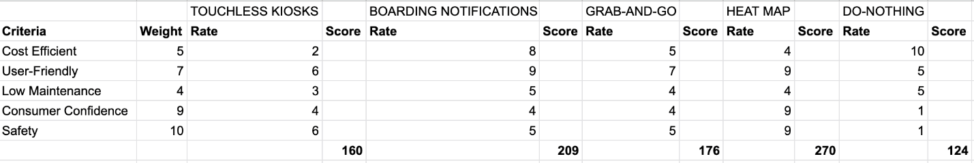
Figure 5: Multiple Criterion Decision Analysis Matrix
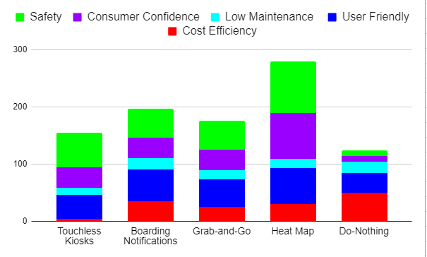
Figure 6: Solution Diagram

Other Considerations
Other considerations presents the other factors that were discussed while developing the optimal solution. These considerations did not align with any pre-existing category but were significant enough to warrant consideration.
The most important additional consideration is the functionality of the existing Indianapolis Airport app. The existing app developed by ProDIGIQ is available on the Apple App Store and Google Play store. However, the app is insufficient for the proposed solution. The app was not built with heat map functionality in mind and is also outdated and reported as unusable for android users. The iOS software received an update but is not useful for the implementation of the heat map. The heat map solution is best implemented in a stand-alone application. This heat map app can coexist with the ProDIGIQ Indianapolis Airport app.

Proposed System
The multiple criterion decision analysis matrix was used to compare the alternative solutions and find the optimal solution. This matrix shows that the heat map is the optimal solution based on criteria weighted by the Indianapolis Airport. This section contains all aspects of the solution, including how the heat map cures the symptoms related to the airport’s problem, how it solves the problem statement, and what specifications are needed to implement the solution. To better understand the solution and how it solves the airport’s problem, an analysis of each symptom is required.

Symptoms of the Problem
The symptoms list contains all of the symptoms related to the problem and they will be addressed.
40% of concessions are closed.
The heat map will provide a visual to the consumer, allowing the user to see specific areas of the boarding process and how populated those areas are. Based on the population density of different concessions and retail stores, passengers may choose lower trafficked stores to shop at while they wait to board the aircraft. Because these lower trafficked areas may be desirable to shop at by the consumer, these once closed concessions will need to reopen.
$5.5 million loss from concessions due to COVID-19.
Implementing the heat map will encourage passengers to use more amenities, shop at retail stores, and order from restaurants more frequently. As customers shop more, concession revenue will increase.

Lack of social distancing around concessions.
The heat map within the application allows passengers to view, then travel to lower trafficked areas. The high heat signature alert settings within the infrared cameras will notify security when areas of the boarding process are too densely populated, allowing for security to disperse crowds. This information can be utilized by the airport for additional social distancing measures if necessary.
Due to the spread of COVID, passengers do not feel safe in public areas.
The real-time information provided by the heat map allows passengers to make safety-conscious decisions while in the boarding area.
Consumer confidence is at an all-time low for air travel.
The app instills greater confidence in the passenger by giving them the ability to choose where they want to go in the boarding area based on a visual interpretation of specific amenities. Passengers are better able to social distance based on real-time information, thus allowing them to make confident decisions on where to go.
Indianapolis Airport must provide customer service without sacrificing a healthy environment in the boarding process.
The heat map is an immersive solution that addresses each of our symptoms individually and satisfies the problem statement. The solution provides great customer service; customers can make their own choices for their health while not being forced by the airport to comply with COVID-related regulations. This solution requires no human-to-human contact, making this the most optimal solution for the post-COVID world.

Implementation Plan
The implementation plan is a holistic outline that discusses the construction, installation, training, conversion, and maintenance of the implemented solution. Via this plan, the solution will be graded by the success criteria: improved customer confidence, less risk of transmission between customers and employees, a significant reduction in transmission, improved functionality and use of the airport app, and making it safer to navigate the airport. This plan will include every step necessary to implement the solution.
Provided is a wireframe model that demonstrates the implementation plan in action.
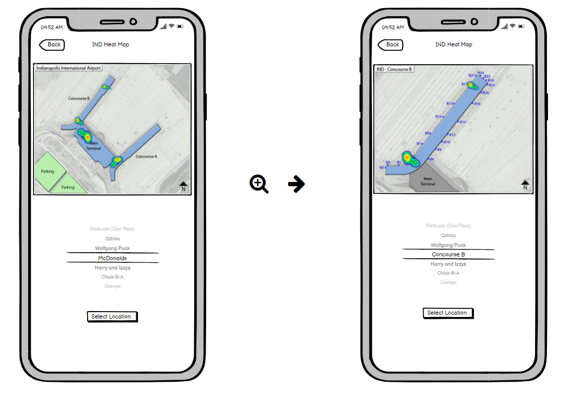
Figure 7: Mobile Application Wireframe

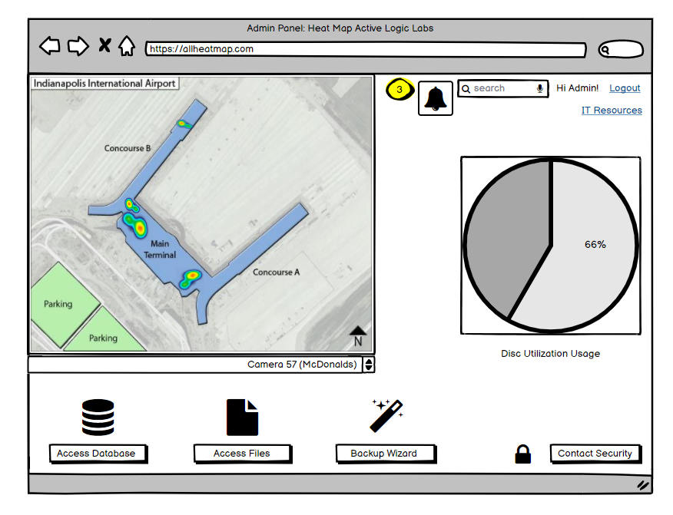
Figure 8: Administration Panel Wireframe

Construction Plan
This will include information about how both the software and the application will be made.
Research, Design, and Planning: 120 hours
This covers everything from the conceptualization of the entire application to the beginning of the development process.
Base setup, Architecture, and UI development: 120 hours
This includes a purposeful base layout to create hierarchy and priority and to make sure the whole system can communicate properly.
Mobile Application: 320 hours
This involves the layout of all features and designs of the mobile application to integrate analytics.
Administrative Panel: 160 hours
This includes building the interface to allow employees to view select data and information and to make modifications where necessary.
Testing and Deployment: 120 hours
This includes testing both the hardware and software. This will ensure the hardware is correctly gathering data, and the software is correctly parsing data.
Hardware
The thermal cameras are specialty surveillance devices that use infrared technology to detect heat signatures and assign temperatures to a value for each pixel. Multiple thermal cameras will be networked together to create data points for the heat map of the boarding area.
- FLIR T4390BT Tri-Mode (IP, HD-CVI, Analog) Bullet Thermal Cameras
  - Connected to Indianapolis Airport systems over ethernet
  - 50º field of view
  - Mounted from a 35ft ceiling
  - Each camera can view 1739.72 square feet
  - The boarding area stretches 673,000 square feet
  - Given equal spacing, this totals to 387 cameras
  - FLIR Camera: $2,189
  - Total: $847,143
The kiosks are 55-inch dual-sided standing monitors that will display a live view of the heat map on both sides to promote social distancing. The kiosks will be connected via ethernet, directly to the Indianapolis Airport’s network infrastructure. The WiFi functionality and USB ports will be disabled for security purposes. An infographic will be displayed across the bottom of the monitor promoting the app.
- DisplayIt! 55-inch Double-Sided Non-Touch Kiosk
  - DisplayIt! Kiosk: $4,468
  - (2) Synced 55 inch LCD Panels with LED Display
  - One kiosk needed at the beginning of each concourse
  - Given two concourses, two kiosks are needed
  - Total: $8,936
- Total Cost of Cameras: $847,143
- Total Cost of Kiosks: $8,936
- Installation Cost: $54,000
- Total Hardware Cost: $910,079
Software and Application
The software will run on the existing Indianapolis Airport system and will receive its input via the thermal cameras. The software will receive the outputted temperature data and camera feeds, then performs an algorithm to parse them together. The software’s final output is then superimposed over a map of the boarding area to display a heat map.
The application is a mobile interface, available on iOS and Android, that displays the superimposed heat map to smartphones. The parsed heat map from the Indianapolis Airport network is transferred via TCP/IP to the application’s cloud. The application appropriately displays a heat map of the boarding area to any passenger.
- Research, Design, and Planning: $16,200
- Base Setup, Architecture and User Interface Development: $16,200
- Mobile Application: $43,200
- Administrative Panel: $21,600
- Testing and Deployment: $16,200
- Total: $155,250
  - 20% Annual Updating and Maintenance Fees: $31,050
Data Storage
The heat map data will be stored using the Indianapolis Airport’s existing network infrastructure. The database is consistently recording and storing the output from the parsing software.
Total Cost of System: $1,175,329

Installation Plan
This plan will cover how many cameras are needed and at what range, how to load the software onto the servers, and get the complete system up and running.
- Mounting cameras every 1739 square feet throughout the airport
- Installing one kiosk at the beginning of each concourse (two total)
- Installing one kiosk at the beginning of the civic plaza
- Connecting all camera feeds and kiosks to a central server
- Downloading and installing the software onto the internal servers
- Ensuring the communication between the hardware and software is functioning properly
- Complete installation time needed: 400 hours
Figure 9 shows the complete process as to how the hardware and software will communicate properly for the application to function in an easily readable way.
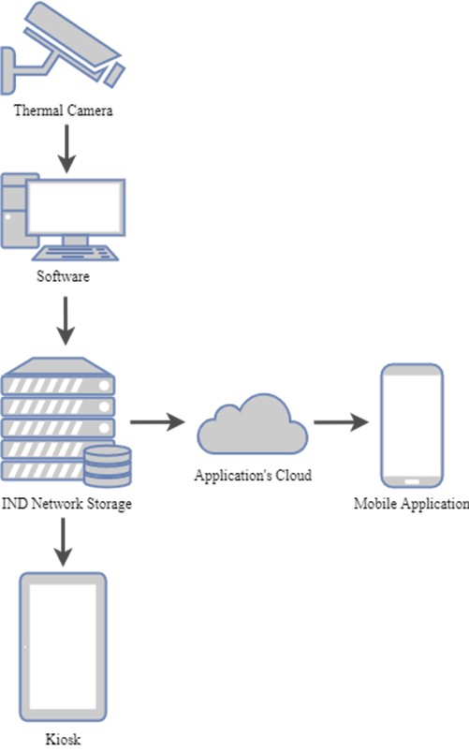
Figure 9: Systems Map

Training Plan
The training plan will explain how to use the administrative panel properly. This includes keeping track of the disk utilization, using the backup wizard, gaining access to files, and gaining access to the database. It will also explain how to notify security whenever a large gathering that does not meet standard protocol has occurred, and how to drill into specific cameras to see live footage of the select area. The client will receive the full training plan when the client has received the software.

Conversion Plan
This plan provides instructions on how to transfer operations from the As-Is business process map to the To-Be business process map. The conversion plan will outline how, when, and where the system will change. This will also include a schedule that details the timeline for the installation and development of the software.
Previously, the As-Is business process map was centered around the boarding process and the decisions a passenger may make while walking through either concourse. The To-Be business process map is now oriented around the use of the heat-map and how it changes the airport experience. The total process to develop and install the heat map will take seventeen weeks between installation, development, and testing of the hardware and software.
Week 1: Thermal cameras installed
- Ten people installing 387 cameras that take an hour each with a forty-hour work week adds up to a week of installation.
Week 2-4: Software development
- Software development will take 120 hours between two full-time developers for the research, design, and planning of the application. Set-up, architecture, and user-interface development will take another 120 hours for a total of three weeks.
Week 5-9: Camera feeds and kiosk set-up
- Set-up of the kiosks and camera feeds will take 400 hours for a total of five weeks.
Week 10-13: Mobile Application Development
- Development of the mobile application will take 320 hours between the two developers for a total of four weeks.
Week 14-15: Administrative Panel
- The administrative panel will take 160 hours to create and set-up.
Week 16-17: Testing and Deployment
- The testing and deployment of the system will take a week and a half to ensure proper installation and functionality.

Maintenance Plan
This will include all steps necessary for the proper upkeep, future adaptation, and necessary upgrades to keep the system functioning. The maintenance plan will also walk through the intricacies of the problem and how they are affecting the airport.

Hardware
This includes maintenance of the kiosks and thermal cameras. This will include upgrading, repairing, replacing, and additional hardware.
- Replacing any old or outdated thermal cameras or kiosks.
- Fixing any damaged or malfunctioning cameras or kiosks.
- Adding additional cameras to areas of the airport that Indianapolis wants to expand the system to cover.
- Adding in additional kiosks in commonly trafficked areas to give passengers a better visual of their surroundings.
- Maintaining up-to-date documentation.

Software
This includes sending patches, bug fixes, installing software on replaced hardware, and updating new versions.
- Patches will need to be applied periodically in order to keep the system secure.
- When new hardware is added or replaced into the system; the software will need to be configured for each of the new devices.
- Updating to new versions of software to replace the software currently in use.
- When software patches, bug fixes, or software updates is applied to the system’s software, a new version of the application will be made available to maintain compatibility.
- Maintaining up-to-date documentation.

Security
This will include consumer security, administrative security, and system security.
- Secure sockets layer (SSL) will be used to encrypt consumer communications within the app to ensure airport data is protected.
- Only the IT administrator will have access to the administrative panel.
- Monitoring and complying with security and privacy regulations.
- Maintaining up-to-date documentation.

Backup and Disaster Recovery

This includes the system backup to maintain data integrity.
- Using a backup wizard in the administrative panel to back up the heat map data to defend against ransomware attacks and data corruption.
- Maintaining up-to-date documentation.

Post-Implementation Review
The post-implementation plan will include the post-implementation review, the review of success criteria, and the trigger. These subsections will outline the steps that will be taken after the implementation of the system.

Review of Success Criteria
The review of the success criteria references each criterion and assigns it a measurable attribute to ensure that the implemented solution is functional and successful.
- Improved customer confidence in the safety of the airport.
  - Take surveys on the perception of the passenger experience.
  - Measure passenger spending within shops and concessions.
- Lowered risk of transmission between customers and employees.
  - More effective divider placement.
  - More social distancing measures.
- Increased smartphone integration.
  - Measure download and use data from application.
  - Measure the change in heat density post-implementation.
- Safer to navigate the airport.
  - More social distancing measures
  - Measure the change in heat density post-implementation.

Trigger
The trigger will indicate when additional consulting needs to be performed to upkeep and update the system as needed. In addition, the trigger will notify the airport when the system is no longer applicable.
- If the airport servers reach their capacity, then data for “x” amount of time will be deleted to allow more storage space.
- New versions of the software have been released.
- If the Indianapolis Airport feels an expansion of the system is warranted, additional consulting will be supplied to ensure all expectations are functional.
- If the software development company fails to meet the expectations of the project, the consultants will be present to ensure that the new software development company can support the needs of the system.

Exit Strategy
This plan states the course of action the Indianapolis Airport needs to take if they need to back out of the deal. The terms of the buyout agreement will depend on the amount of labor hours committed to the solution, and what phase of the solution the project is in. Some reasons as to why the Indianapolis airport would want to terminate their contract would include:
- If the application does not meet the requirements needed to function and display the heat map appropriately.
- The implemented system does not produce expected results.
- Miscommunication between the client and the consulting team
- Software vendor stops support of the system.
- A new executive rejects the system and wants to put money elsewhere.
- The software vendor lies about the limitations of the software.
- New technology emerges that causes the Indianapolis Airport to lose interest in the optimal solution.
- The company that the Indianapolis Airport has bid to has been bought out by another company.
- The bid does not meet set financial guidelines by the airport

APPENDIX A: Root Cause Analysis Diagram
The diagram shown was developed to arrive at the final root cause. This includes five distinctly grouped sections that cover various topics. From the root cause diagram, key issues about the Indianapolis Airport boarding process were identified. From left to right, this includes marketing with airlines, encouraging human behavior, raising consumer confidence levels, implementing contact tracing, and the need to minimize human contact.

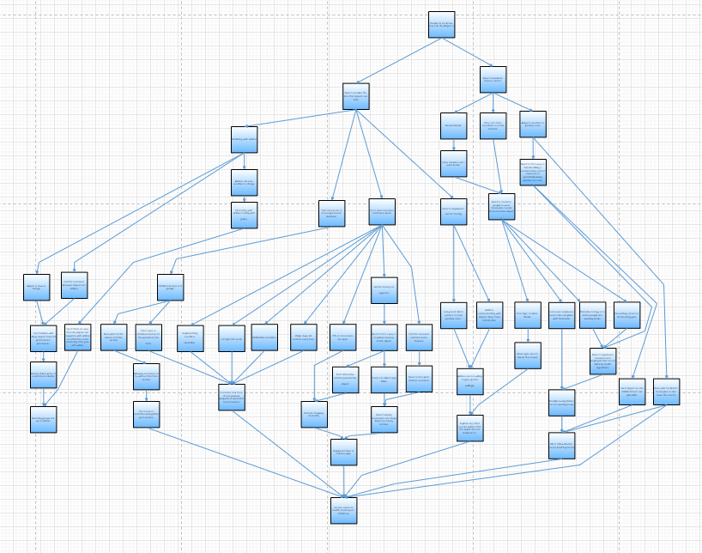
Figure 10: Root Cause Analysis (Large)

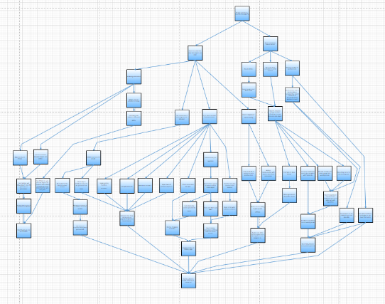
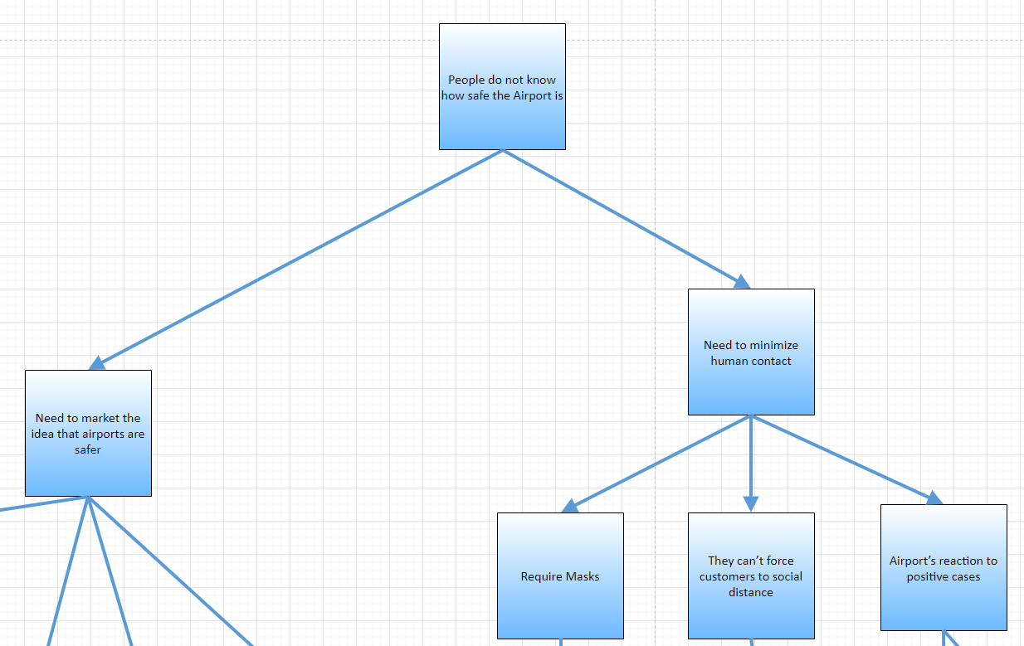
Root Cause Analysis Problem Statement
Large Root Cause Analysis 2
Figure 11: Root Cause Analysis Part 1

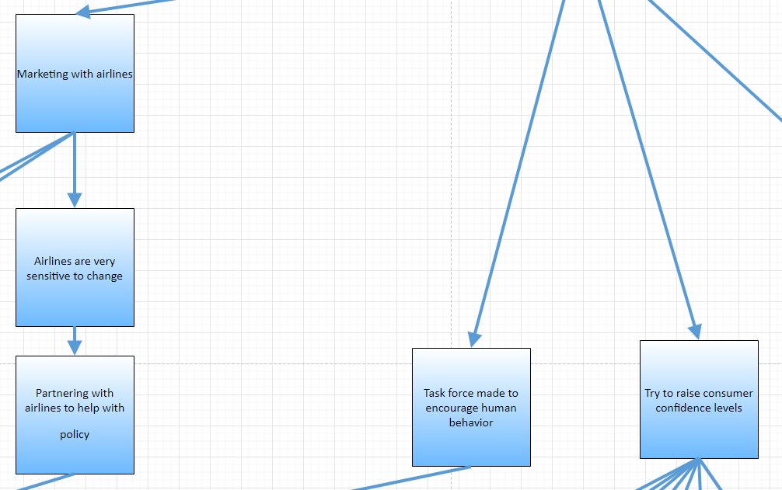
Figure 12: Root Cause Analysis Part 2

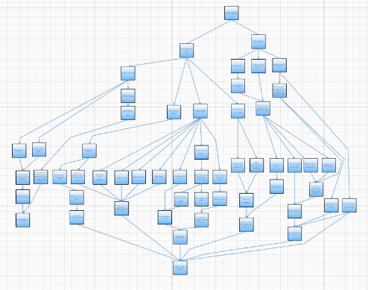
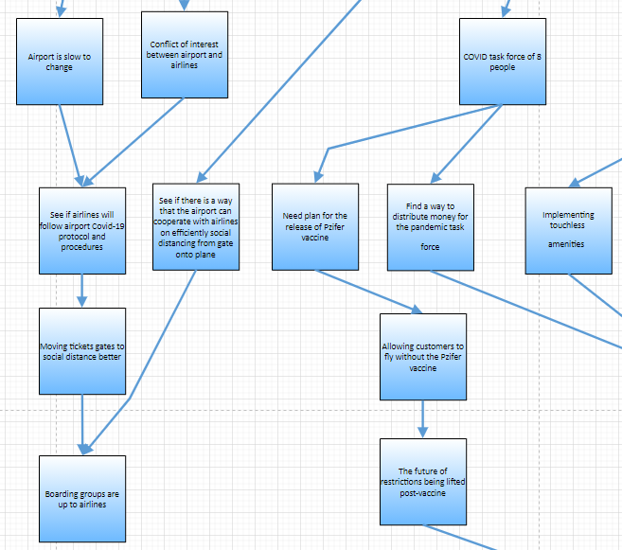
Figure 13: Root Cause Analysis Part 3

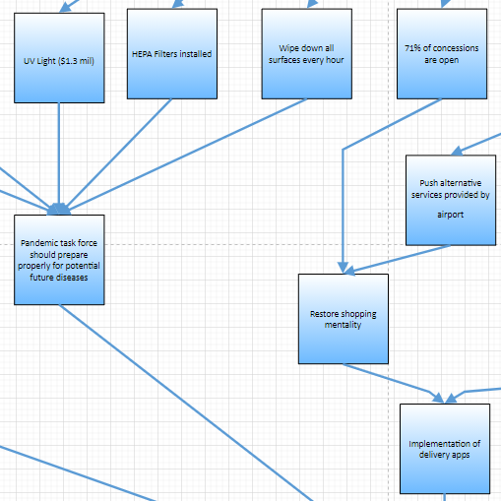
Figure 14: Root Cause Analysis Part 4

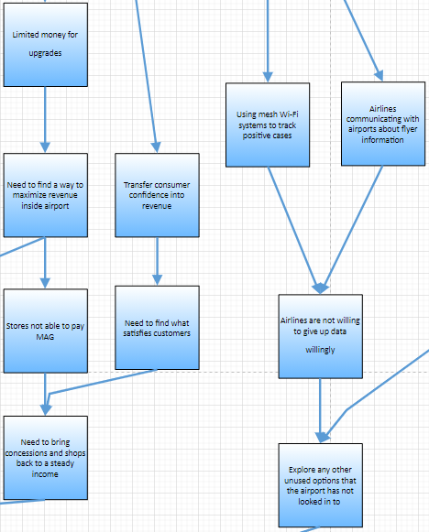
Figure 15: Root Cause Analysis Part 5

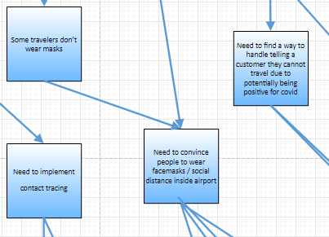
Figure 16: Root Cause Analysis Part 6

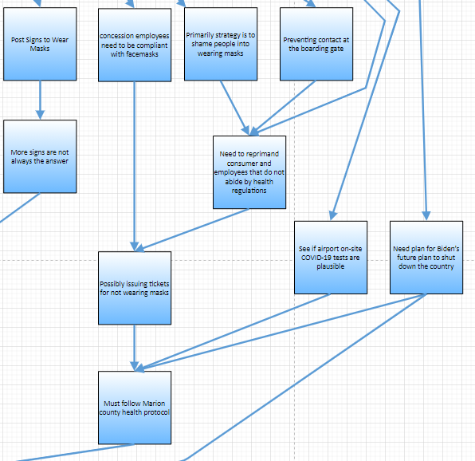
Figure 17: Root Cause Analysis Part 7

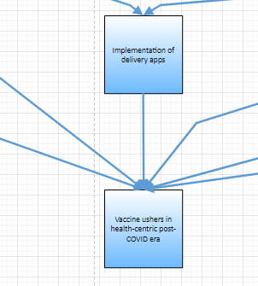
Figure 18: Root Cause Analysis Part 8

APPENDIX B: Boarding As-Is Business Process Diagram
The following appendix is the boarding process for the Indianapolis Airport as it stands currently.

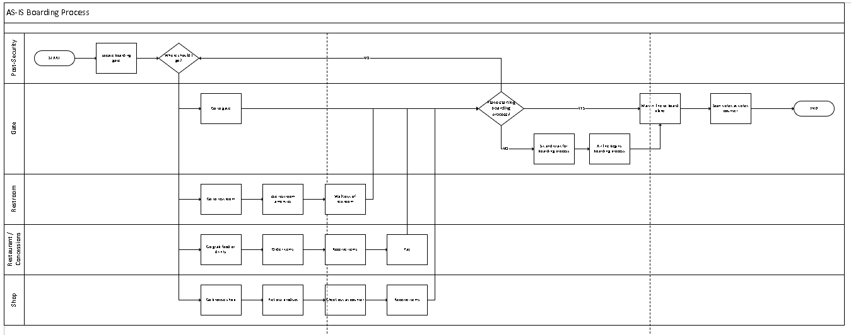
As-Is Process Map (Large)
As-Is Process Map 1
Figure 19: As-Is Business Process (Large)
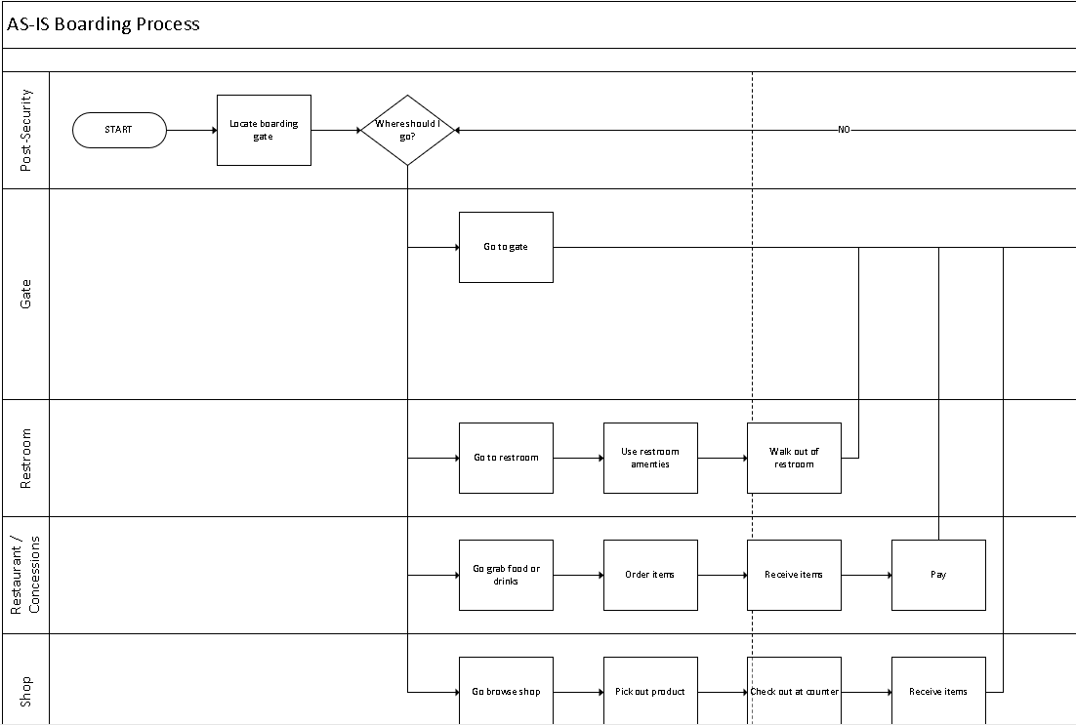
Figure 20: As-Is Business Process Part 1
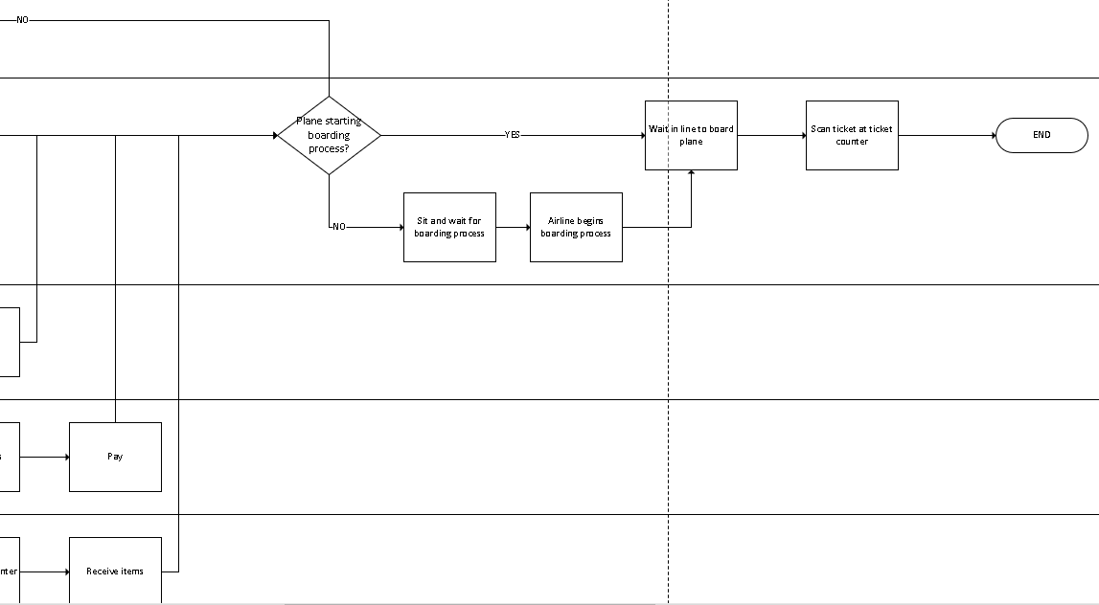
Figure 21: As-Is Business Process Part 2

APPENDIX C: To-Be Business Process Map
The following appendix is the boarding process for the Indianapolis Airport after the solutions are implemented.

Figure 22: To-Be Business Process (Large)

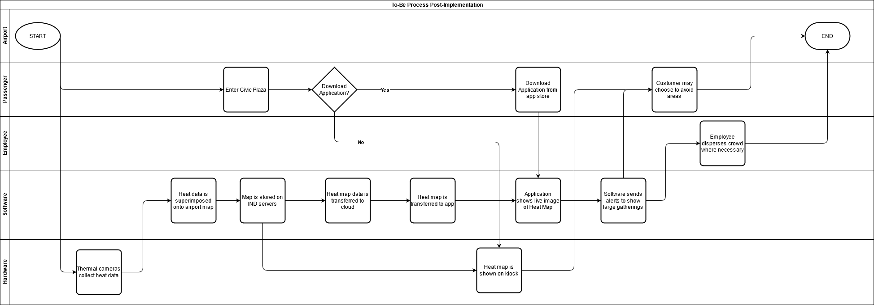
Figure 23: To-Be Process Map (Large)

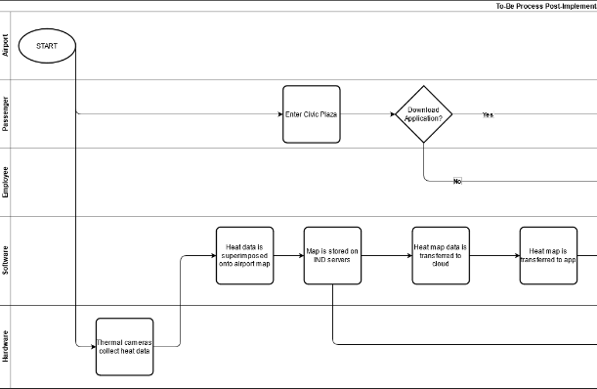
Figure 24:To-Be Process Map (Part 1)

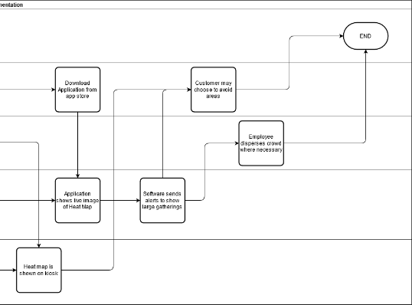
Figure 25: To-Be Process Map (Part 2)

APPENDIX D: Staffing Plan
The following appendix is a collection of all the members from Renegade Technology and their background.

Zachary Siddiq: Project Manager
Zachary Siddiq is the Project Manager at Renegade Technology. He is currently a senior, studying Computer Information Systems at Ball State University.
Zachary’s primary work experience is with Roche Diagnostics, a pharmaceutical company delivering COVID-19 test kits across the United States. As a Material Handling Technician, he distributes the necessary goods from initial packing to final inspection. Additionally, Zachary has served Ball State as a Resident Assistant, developing a residence hall community for over seventy students. The intense responsibility needed to succeed in both jobs enhances Zachary’s ability as a Project Manager.
Siddiq has volunteered as Director of Communications with Cardinal Animation Workshop, a student organization focusing on the animation industry. Through his connections and expertise, he has introduced peers to employees at Walt Disney Animation Studios, Warner Bros., and other esteemed Hollywood studios. Zachary’s ability to communicate with both new acquaintances and familiar peers will serve him well as the Project Manager.
Colin Kerrigan: Communications Specialist
Colin Kerrigan is the Communications Specialist at Renegade Technology. He is currently finishing his senior year in pursuit of a Bachelor's degree in Computer Information Systems.
Colin comes from a family of Thirteen. Living in such a large household has taught him that anything you want in this life must be earned. Strong interpersonal communication skills and problem-solving are key qualities Colin has mastered throughout his lifetime.
Kerrigan has held many positions throughout his career from entry-level to training and managerial positions. He was able to achieve these higher positions due to his excellence in quick-thinking, both analytical and logical, as well as his superb attention to detail, all while being solution-oriented.
Entrepreneur to the core, Colin is constantly looking for innovative possibilities in new concepts and product design. In doing so, he is constantly seeking new methods to complete any task more efficiently.
Adam Rivera: Business Analyst
Adam Rivera is the Business Analyst at Renegade Technology. Adam is a senior at Ball State University and is graduating with a Bachelor of Science with a major in Computer Information Systems this spring.
Adam has worked in the technology field for the past two summers as a Business Analyst intern for Eagle6. Every week he would be greeted with challenges that would force him to communicate regularly with his team and other Business Analysts across different teams. Simultaneously, Adam created and developed documentation for programmers to use. Additionally, Adam has restaurant experience, working directly with customers while creating an inviting and enjoyable experience.
Outside of his occupation, Adam has volunteered at disability camps, working closely with Ball State’s Best Buddies program. Adam plays competitive golf and has experience working in golf tournaments. By obtaining these experiences, Adam was able to gather better communication skills and leadership skills to use within the workforce.

Evan Russomanno: Information Security Analyst
Evan Russomanno is the Information Security Analyst at Renegade Technology. Evan is a senior at Ball State pursuing a bachelor’s degree in Computer Information Systems with a minor in Computer Security.
Evan was a 2019 Techpoint Xtern finalist, which was a rigorous program made to select qualified students for interviews with prominent companies in Indianapolis. Russomanno completed a cybersecurity work sample and was selected among the best applicants.
In the summer of 2020, Evan participated in a cybersecurity research experience for undergraduates at IUPUI, which focused on malware analysis and data provenance. During this time, Evan researched Kali Linux using Wireshark and Cuckoo Sandbox, among other programs.
Through these experiences, Russomanno was able to strengthen his teamwork and problem-solving skills by analyzing the strengths and weaknesses of data provenance systems. This technical knowledge and problem-solving ability ensure Evan is a reliable Information Security Analyst.

Cooper Smolek: Analytics Specialist
Cooper Smolek is the Analytics Specialist at Renegade Technology. Cooper is a Junior Computer Information Systems major, with a minor in Computer Science at Ball State University.
Cooper’s previous jobs included working in the service industry. For three years he was a shift lead at Culver’s location, where he developed efficient multitasking skills, leadership skills, and keen attention to detail. Smolek currently has spent a year working at Root’s Burger Bar, where he has honed his customer service and organization skills.
Previously, Cooper spent a year in a Computer Technology vocational program, where he received hands-on experience working with computer hardware, networks, software, and professional soft-skills. As part of the course, Smolek received his TestOut PC+ certification. These acquired skills in efficiency and organization make Cooper a valuable Analytics Specialist.

APPENDIX E: TEAM STANDARDS
The following appendix explains Renegades Technology’s standards and methodology while working with clientele and colleagues.

TEAM MEMBERS’ INFORMATION
Listed below is the contact information and qualities of the members of Renegade Technology.
Zachary Siddiq, Project Manager
Contact Information: Phone: (317)-476-6665, E-mail: zmsiddiq@bsu.edu
Strengths: Public speaking, multitasking, agile project management
Colin Kerrigan, Communications Specialist
Contact: Phone: (765)-744-8680, E-mail: cakerrigan@bsu.edu
Strengths: Persuasive storytelling, critical thinking, quick-thinking, detail-oriented
Adam Rivera, Business Analyst
Contact Information: Phone: (502)-420-8788, E-mail: arivera7@bsu.edu
Strengths: Documentation, communication, strategic planning, strategic thinking
Evan Russomanno, Information Security Analyst
Contact: Phone: (901)-604-8272, E-mail: edrussomanno@bsu.edu
Strengths: Technical documentation, problem-solving, troubleshooting
Cooper Smolek, Analytics Specialist
Contact: Phone: (219)-241-9596, E-mail: coopersmolek@gmail.com
Strengths: Team-building, organization, analytical thinking
COMMON GOAL(S)
The utmost important goal is to deliver a reliable product that satisfies all possible requirements. Accomplishing this goal requires the group to be prepared, responsible, accountable, and efficient. Every member of the group should perform to the highest degree possible.

Communication
Basic communication will primarily be done over digital methods such as video calls on Zoom and texting over GroupMe to limit in-person contact. A majority of assignments, work, and practice will be completed via video conferences, allowing for ease of access and instantaneous communication. In-person meetings will be held in Bracken Library and in class to further cement group communication and understanding of various projects and topics. This combination of online video calls and physical meetings will ensure clear, concise communication between team members.

Equal Understanding
Team members will communicate with each other to determine meeting and working times. Each team member will communicate within an hour if they are not able to make a meeting time. Renegade Technology holds a high standard for work ethic and makes sure each individual communicates properly with the team in case of an emergency. Every member is responsible not only for the work assigned to them but also for the project as a whole. Each team member must uphold delegated responsibilities and contribute to the team.

Decision-Making
Making decisions is a group process. Working as a complete unit and taking every team member’s opinion into account to deliver the best product possible is imperative. Therefore, team members must agree on major decisions or changes as they arise throughout the project. Minor decisions or changes may be made at the discretion of the individual(s) if need be. If a major disagreement should arise, a team meeting will take place to ensure an appropriate solution.

Accountability
Team members will be held accountable for not only their work but for the entire project as a whole. Those who do not complete their assigned tasks will be contacted directly so any roadblocks or issues can be resolved. Continuous lack of accountability will lead to a verbal warning from the project manager. If a team member is repetitively unreliable, further consequences may ensue.

Access to Information
Team members will have access to multiple applications throughout the project. These applications include but are not limited to Google Drive, Microsoft Outlook, and Canvas. Any additional information that comes from Dr. Fred Kitchens will be forwarded to the team by the Project Manager.

Trust and Respect
Team Members will always be considerate of each other and others around them. This includes treating each other with the respect and dignity that is deserved. Team members will never insult or talk down to each other.

Professionalism
Striving for professionalism during both presentations and working as a team is of utmost importance. This includes wearing a suit and tie to all presentations and demonstrating a professional demeanor. Team members will be respectful of others’ thoughts and opinions and minimize interruptions. Team members must stay positive and strive for a high level of cooperation to deliver the best possible output.

Attendance and Punctuality
Renegade Technology takes attendance and punctuality seriously. Team members are expected to show up to all meetings and presentations at, or before, the expected time and date. If any scheduling conflicts occur, the team member(s) must alert the team at an appropriate time before the scheduled time.

Quality of Work
All work done is representative of a professional setting. This means that all work done will have consistent grammar, wording, and documentation. Any document or presentation completed by the group is to be developed to the highest degree possible to satisfy client needs and requirements.

Consequences for Violating a Standard
A verbal warning will be issued for the first infraction. After a second violation, a meeting will be held to discuss further endeavors with the team without Dr. Kitchens. If a third infraction occurs, another meeting will take place, including Dr. Kitchens. Further violations of standards will result in termination.

Rewards for Following All Norms
Rewards for following all norms include pride in the grade received as well as the satisfaction of accomplishing a goal as a team. Also, these projects and assignments aid to create a more developed team, enhancing our professional skills.

APPENDIX F: Supplemental Industry Analysis
The following appendix is a list of quotes and summaries from references relative to solving the Indianapolis Airport’s problem.

- AIR TRAVEL INDUSTRY
  - POST-COVID FLIGHTS
    - Looking to the Future of Air Travel
      - The interviewees all agreed that COVID-19 has been the hardest challenge for air travel in its entire existence. Some dismiss the idea of airlines removing the middle seat and instead advocate for less interaction with the flight crew and unique technological hygiene solutions such as touchless lavatories. When asked about any silver linings to the slowdown in the aviation industry, an interviewee gives an interesting take. They believe that cargo companies will have a huge win because many unprofitable planes during this period will be converted to cargo planes and potentially sold to cargo companies. Seeing as the Indianapolis International Airport is one of the biggest cargo airports in the country, this may be a valuable piece of information.
        - Harrell, E. (2020, August 17). Looking to the Future of Air Travel. Retrieved November 19, 2020, from https://hbr.org/2020/05/looking-to-the-future-of-air-travel
    - What Should the Future of Aviation Look Like?
      - Luis Felipe de Oliveira, the director-general at Airport Council International, believes that the entire industry will never be the same. He compares 9/11 setting new benchmarks for security to COVID-19 setting new benchmarks for health and safety. He believes most of the industry will make a full recovery in early/mid-2023, but only with consumer confidence that virus transmission cannot be blamed on the aviation industry. Chris Goater, assistant director of corporate communications at the International Air Transport Association, claims the industry’s priority is to work with governments to encourage them to open borders and relax quarantine measures. Most of the interviewees focus on airlines/airports needing to convince customers that it is safe to fly again. They also stress increased health measures, with a specific focus on non-touch devices/services.
        - Berti, A. (2020, November 12). Roundtable: What should the future of aviation look like? Retrieved November 19, 2020, from https://www.airport-technology.com/features/aviation-future-covid-19/
    - The Future of Airports
      - This mini-magazine from WSP, a research and professional services firm, talks about the future of airports from a non-COVID-19 angle. It lays out many interesting statistics, such as the growing Asian/Middle Eastern market, the increasing focus on infrastructure, and more. They also mention ‘invisible security’ and many advances in touchless technologies, such as biometric face detection. The move to a cleaner, seamless, and touchless airport seems to have been the direction many were moving towards even before COVID-19. There also seems to be a focus on becoming ‘greener’. This includes green energy, literal plants in the airport, being self-sustainable, and encouraging airliners to move towards carbon neutrality. They touch on airports slowly becoming cities, which seems to be a recurring theme in the industry.
        - Puckett, K. (2019, January). The Future of Airports. Retrieved November 19, 2020, from http://cdn.wsp-pb.com/e34d2j/the-future-of-airports-a4_web.pdf
    - The Future of Airports Post COVID-19
      - Airline capacity is down 70-80% from April 2019 to April 2020, and many sources point to the capacity never making a full recovery without radical change. Many airports in the future will continue to gravitate towards non-passenger forms of revenue, even after COVID-19. This can include non-flying related services, cargo planes, parking services, concessions, and even real estate rental. Another point that is reiterated is the acceleration of developing biometrics and contactless technology. The researchers separate opportunities for airports into three distinct categories: immediate opportunities, mid-term prospects, and long-term goals. The overall conclusion is that airports will continue to innovate and become more diverse to not only prepare in case of another pandemic but to become broader entities as a whole.
        - Serrano, F., & Kazda, A. (2020). The Future of Airports Post COVID-19. Journal of Air Transport Management, 89. Retrieved November 19, 2020, from https://www.sciencedirect.com/science/article/pii/S0969699720304841
    - Designing the ‘Airport of the Future’
      - Luis Vidal discusses the idea that airport infrastructures evolve in ‘generations’ that are approximately thirty years apart. Vidal discusses how a new ‘fifth generation’ of airport infrastructure is about to emerge from the ashes of the COVID-19 crisis. Airports will continue to develop with public health and technological innovation closer in mind to become safer, sleeker, and more efficient. As iterated by many other sources, this would involve being ‘flexible’, or implementing new, unseen technologies to make the airport experience more seamless. This includes invisible security checkpoints, non-touch check-in, and even an electronic luggage pick-up labeling system.
        - Vidal, L. (2020, August 13). Designing the ‘Airport of the Future’. Retrieved November 19, 2020, from https://www.aviationpros.com/airports/consultants/architecture/article/21143854/designing-the-airport-of-the-future
    - How The Airline Industry Will Transform Itself As It Comes Back From Coronavirus
      - The detrimental impact COVID-19 has made on the airline industry is too severe for business class flyers to ever be what it once was. Although leisure class flyers will eventually get back to prior numbers, it will take quite a bit of time. Bigger airlines with the most exposure will be the only airlines left while smaller airlines may not make it. This impact directly affects Indianapolis International Airport commerce. COVID-19 has impacted potential passenger’s decisions on whether to fly, like the effects of 9/11 regarding safety. To reach consumer levels the Indianapolis Airport had before COVID-19, the airport should focus on creating consumer awareness of the safety precautions they have taken.
        - “The world’s commercial airlines and other aviation businesses face significant financial stress and perhaps bankruptcy in the coming months from the unprecedented, unexpected, and broad shutdown of travel due to the rapid spread of Covid-19.”
        - “The industry faces massive pressure on cash flow from extraordinary travel restrictions and a tremendous drop in passenger demand.”
        - “It would be a mistake to assume the post-2020 industry will look the same as the one prior to the COVID-19 crisis.”
        - “Business travel permanently impaired, leisure travel will take time.”
          - Donovan, D. (2020, March 30). How The Airline Industry Will Transform Itself As It Comes Back From Coronavirus. Forbes. https://www.forbes.com/sites/deandonovan/2020/03/30/how-the-airline-industry-will-transform-itself-as-it-comes-back-from-cornonavirus/?sh=3b17a6b167b9
    - How COVID-19 Is Transforming Global Aviation’s Outlook
      - Indianapolis International Airport not only faces a plummet in demand for flight passengers and shopping consumers in the post-security boarding area but also staying up to date with what international airports are doing to help secure COVID-19 and prevent the spread. In this article, Wyman discusses how almost half of the world’s population have been blocked off from leaving, and that are tourists being blocked off from entering their country. So, we face another factor affecting diminishing flight demand as some people who may want to fly are strictly prohibited via governing officials.
        - “Unless the virus is effectively contained within the next couple of months, we expect the depressed demand environment and reduced global revenue passenger kilometers (RPKs) — a widely accepted metric of air travel demand — to persist well into 2021.”
        - “Recovery in aviation may take longer than many had hoped. Travel may not return to normal until the virus is conquered worldwide.”
        - “The Pew Research Center estimates that three billion people live in countries where borders have been completely closed to tourists, business travelers, and others who are neither citizens nor residents.”
        - “On March 23, the International Air Transport Association (IATA) increased its global estimate on lost passenger airline revenue from the latest strain of coronavirus to $252 billion for 2020. That was up from an estimated $113 billion on March 5 and $29 billion two weeks before that.”
        - “Given that virus containment and economic recovery will be uneven, it will be vital to monitor developments in countries where the virus appears to be contained and detect early signals of rebound amid an otherwise noisy environment.”
          - Wyman, O. (2020, May 23). How COVID-19 Is Transforming Global Aviation’s Outlook. Forbes. https://www.forbes.com/sites/oliverwyman/2020/04/06/how-covid-19-is-transforming-global-aviations-outlook/?sh=40c1e9761b9c
    - The New Airport Security Sector in A Post-Covid-19 World
      - Analyzing safety and security in airports is vital to assuring confidence to any potential customer considering flying as a means of transportation. Sylvain Lefoyer mentions a decrease in the number of manual physical contact searches. On one hand, this can be seen as a positive step to preventing the spread of coronavirus, but on the other, it can diminish the levels of consumer’s confidence regarding safety. However, even with security systems, we are not able to create better precautions to uphold health regulations. We must uphold an above-satisfactory level of security.
        - “Despite the continued impact of the pandemic around the world, states have started loosening travel restrictions as the normalisation of sanitary measures becomes widespread”
        - “As one can imagine, manual searches of persons (often referred to as pat-downs) will be limited as much as practicable during the crisis.”
        - “One of the cornerstones of those guidelines is that adequate security levels shall be maintained at all times in order not to introduce vulnerabilities in the system. This is a fundamental principle that cannot be transgressed.”
        - “Crowd control systems can help manage adequate physical distancing at queues and security checkpoints; modern screening equipment, such as explosive detection systems for cabin baggage, allows for faster screening processes with lower rates of false alarms and increased detection capability; and biometric systems are an effective tool for access control, allowing for contactless identity checks.”
        - “Accomplishing consistent security levels around the different regions of the world, would contribute to increasing public confidence in the air transport system.”
          - International Airport Review. (2020, November 16). The new airport security sector in a post-COVID-19 world. https://www.internationalairportreview.com/article/144490/new-airport-security-sector-post-covid-19/
    - 11 Ways the Pandemic Will Change Travel
      - Upholding Airport security while still maintaining health regulations set in place by the government are two incredibly important aspects that are of the most concern to people looking to travel. However, most people looking to travel are only traveling a few hundred miles, privately. Long-distance flights may be cheaper than ever right now, but another cause for concern lies within the costs of the destination people fly to. Restaurants, entertainment venues, etc. are raising entry costs and menu prices because of the lack of customers.
        - “Won’t be surprising to see significantly more biometric screening and touchless elements within the next six to eight months. He envisioned a system that could scan his face, direct him to a TSA lane and use biometrics to let him buy anything in the airport without taking his wallet out.”
        - “If I could go from curb to gate without physically touching anything, it kind of solves some of the pandemic issues,” he said. “I think there’s a lot of people who would prefer to do that.”
        - “…revamping public spaces to allow for physical distancing, installing barriers, moving toward touchless technology and stepping up sanitation.”
        - “…some worry that the impact of the pandemic on airlines may translate to less travelers flying abroad, and, as a result, will make other parts of international travel more expensive.”
          - Sampson, H., & Compton, N. B. (2020, June 15). 11 ways the pandemic will change travel. Washington Post. https://www.washingtonpost.com/travel/2020/06/15/11-ways-pandemic-will-change-travel/
    - What Will Air Travel Look Like Post-COVID-19?
      - Scott Duncan is a partner at Skidmore, Owings & Merrill. He has designed several high-profile and trafficked terminals. Through ingenuity, he has proposed multiple creative and ingenious ideas we could implement in our airports. From small bubbles on airplanes to outdoor waiting areas at airports, we are given many proposals of methods for making flying vastly safe and cleaner. The suggestions Duncan proposes throughout this article lead to one huge point; “You really don’t need to interact with a human to get on a plane.” Implementing solutions to support this can widely secure potential flyer’s confidence, thus speeding along the recovery process.
        - “Airlines have already enacted drastic changes: Delta blocked middle seats and boards 10 guests at a time. JetBlue suspended beverage and snack service. Many are capping cabin occupancy at 50% when possible, and all are increasing the rigor of their sanitization process.”
        - “…client’s interests changed pre- and post-coronavirus: natural ventilation, sunlight, and green areas, once aesthetic add-ons, became priorities.”
        - “Outdoor spaces are going from ‘Oh, this is nice to have’ to ‘It’s a genuine amenity and maybe a necessity to travel.”
        - “There could be beautiful waiting areas that are remote from the gate lounge with a spaced-out, pod environment. It’s cleaned frequently, and it’s comfortable. They’re likely a little bit away, but your phone will notify you when it’s time to board. We will see more things that isolate people spatially.”
        - “Bright-colored grids that tell where to stand six feet apart in customs, among other visual social distancing cues. Last week, the Vienna airport began offering COVID-19 tests upon departure and arrival for 190 euros. Passengers head to a lab site near the terminals to undergo a PCR test. The results take three hours. If all clear, they can skip the (otherwise mandatory) 14-day quarantine. If positive, the Austrian authorities are notified.”
        - “You really don’t need to interact with a human to get on a plane.”
        - “So what will air travel look like six months, one year, two years from now? Right now, there are some innovations, creations, and ideas. But much of it is still up in the air.”
          - Taylor, E. (2020, May 12). What Will Air Travel Look Like Post-COVID 19? Vogue. https://www.vogue.com/article/what-will-the-future-of-air-travel-look-like
    - Coronavirus roundtable: How is the aviation industry responding to the COVID-19 pandemic?
      - The COVID-19 pandemic is causing revenue to drop drastically. The main issue is the ideology that air travel is unsafe. This will cause reduced airline travel, which directly results in less revenue coming into the actual airports themselves. This results in airports closing down terminals, sometimes entire airports, and operating under minimum staffing levels.
        - “We had already seen significant impacts on passenger numbers before wider travel restrictions were introduced in Australia in March 2020. In February 2020, Australia’s two largest airports saw declines in international passenger numbers of approximately 17 percent compared to the same month in 2019.”
        - “Airport revenue generation is directly linked to traffic levels. The flight bans and cancellations are leading to less flights, hence less aeronautical revenue coming in. Unlike other players in the aviation industry, when traffic demand falls, airports have limited ways of reducing costs. The cost of operating airport infrastructure remains the same, and airports can’t close down or relocate terminals and runways.”
        - “with zero or close-to-zero passengers, airports across the UK have significantly downscaled their passenger operations. From closing sections of a terminal to closing whole terminals and even entire airports, sometimes only to passengers but also wholly closing down to all traffic.”
        - “Airports have activated their business continuity plans, are running virtual Emergency Operations Centers (EOC), and identifying minimum staffing levels and shift work to ensure essential services continue for as long as possible.”
          - Hockley, L. (2020, April 15). How is the aviation industry responding to the COVID-19 pandemic? Retrieved November 19, 2020, from https://www.internationalairportreview.com/article/114585/aviation-industry-covid-19-pandemic/
    - Airport Challenges in Reacting to Covid-19
      - The sharp decline in airline demand causes airports to adapt and reduce airport management. Airports are currently trying to minimize the risk of operations by social distancing and taking other protective measures that have been viable solutions to reduce the spread of COVID-19.
        - “The sharp decline in flight demand leads to falling revenues and requires airport management to implement adapted operational concepts and while reducing costs in the short term.”
        - “For airport management the task is to plan and organize a smooth recovery of operations and minimizing the risks of disruptive operations while at the same making quick decisions and ensure continuous adaptation.”
        - “Social distancing, staff protection measures and additional processes have a massive impact on passenger flow, system capacity, transfer times and travel duration.”
          - Airport Research Center. (2020, November 18). Airport Challenges in Reacting to Covid-19. ARC. https://arc.de/airport-challenges-in-reacting-to-covid-19/.
    - Young, Sinema, Cruz introduce bill to incentivize more efficient airport construction
      - A recent bill introduced in the US Senate would incentivize airports to finish construction at a more efficient pace. This will prevent taxpayers from spending more money than necessary. For the Indianapolis International Airport, this may incentivize construction even during the financial hardship brought on by COVID-19.
        - “As the Crossroads of America, it is critical that Indiana’s airports continue to make important infrastructure investments. Hoosier airports are frequently working to improve their infrastructure and aviation safety with projects on their taxiways and runways, and it’s our job to help them complete those critical aviation infrastructure projects in the most efficient way possible.”
          - Young, Sinema, Cruz Introduce Bill to Incentivize More Efficient Airport Construction. (2020, June 15). Retrieved December 08, 2020, from https://www.young.senate.gov/newsroom/press-releases/young-sinema-cruz-introduce-bill-to-incentivize-more-efficient-airport-construction-
  - SAFETY MEASURES AND PRECAUTIONS
    - Air Travel Adapts to Make Travel Safer
      - Many new technologies inside airports are being developed to decrease the spread of viruses and increase public safety and health. One example is Pittsburgh International Airport working with Carnegie Robotics to create an automated cleaning robot. This robot uses water pressure, chemical disinfectant, and in the future will be fitted with an Ultraviolet-C light to help kill germs and keep the airport clean. Also, airlines are working on biometric devices to scan your face and identify you rather than interacting with a gate agent. A new touchless medical device called the ‘Symptom Sense’ reads more than just your temperature; it also gathers your blood-oxygen levels, heart rate, and respiration rate without touching you. The creator of the device, Soter Technologies, is in talks with various airports and the TSA about implementing it.
          - Snow, J. (2020, August 13). Nano needles. Facial recognition. Air travel adapts to make travel safer. Retrieved November 19, 2020, from https://www.nationalgeographic.com/travel/2020/08/the-future-of-flying-is-going-high-tech-due-to-coronavirus-cvd/
    - Hamburg Airport’s comprehensive COVID-19 response: ensuring safe travel from check-in to boarding
      - The Indianapolis Airport is concerned about social distancing in lines and needs a better way of detecting COVID-19 positive passengers. Temperature checks are not good enough. High-temperature checks do not mean somebody is COVID positive and the airport is not comfortable turning passengers with high temperatures away.
        - “Passengers can purchase face masks, disinfectant wipes and disinfectant gels for their travels at self-service kiosks, For non-contact check-in, the airlines offer mobile check-in facilities, as well as the check-in and self bag drop kiosks at the airport. With a mobile service team in the terminals and on the Passenger Pier, the airport is providing additional support and information for all passengers. There is a COVID-19 test centre at Hamburg Airport operated by biotech company Centogene.”
          - Falconer, R. (2020, November 17). Hamburg Airport's comprehensive COVID-19 response: ensuring safe travel from check-in to boarding. http://www.airport-business.com/2020/11/hamburg-airports-comprehensive-covid-19-response-ensuring-safe-travel-check-boarding/
    - Coronavirus Risk Considered 'Very Low' With The Proper Measures In Place At Beverly Regional Airport
      - Customer hesitancy is a major problem for the Indianapolis Airport. They are operating with a severe decline in passengers. Parking went from 260,000 a day to around 25,000. If passengers know an aircraft is safer than grocery stores or eating out, then more people will be willing to fly.
        - “…researchers maintain that the risk of COVID-19 transmission onboard aircraft is well below that of other routine activities during the pandemic, such as grocery shopping or eating out.”
        - “The bottom line is this layered approach adds up to a remarkably safe environment for people to travel with one airline executive saying that "risk of Covid-19 transmission is virtually non-existent."
          - Desk, P. R. (2020, November 15). Coronavirus Risk Considered 'Very Low' With The Proper Measures In Place At Beverly Regional Airport. Hamilton-Wenham, MA Patch. https://patch.com/massachusetts/hamilton-wenham/coronavirus-risk-considered-very-low-proper-measures-place-beverly.
    - Social Distancing At The Airport Is Really Difficult Right Now
      - Airports are running into the issue that social distancing is becoming more difficult than some may realize. This article talks about how half of the airport vendors in Phoenix are closed, thus congregating people to the few concessions and shops that were open. Forbes also went on to discuss that the crowds around the gates impose problems as well, creating the idea that airport social distancing is improbable.
        - “At least half of the airport vendors in Phoenix were closed, meaning anyone who wanted a cup of coffee or something to eat had less options to choose from. What that translated to yesterday were long lines with people congregated in close quarters (20-minute wait for a coffee at Starbucks, extended lines at Wendy’s and McDonalds, etc). So while there were less people overall at the airport, those people were being funneled closer together as a reality of the closures.”
        - “Things are still crowded around the gates, too. Because of the way most airlines board, you had your typical gathering around the boarding gate, people standing shoulder to shoulder blocking everyone and others pushing their way through to board.”
          - McGough, W. (2020, June 18). Social Distancing At The Airport Is Really Difficult Right Now. Forbes. https://www.forbes.com/sites/willmcgough/2020/06/18/covid-19-travel-update-social-distancing-at-the-airport-is-really-difficult-right-now/?sh=47e093fc682d.
  - COVID Testing Before Flights
    - Itching to Travel? Preflight Coronavirus Tests Are Getting Passengers in The Air
      - Air travel is significantly down, preflight testing could be a solution to get numbers back up.
        - “Now they're offering one more thing in hopes of putting travelers' minds at ease about flying: testing for the coronavirus at the airport, before you board your flight. The tests are allowing some travelers to reschedule and take vacations they had to cancel or postpone months ago.”
        - “Other airports offering preflight coronavirus testing include Newark, New York's JFK, Hartford and Oakland, which is offering testing for Hawaii-bound travelers for free.”
        - "We got a rapid test, it took about 30 minutes, you know, a nasal swab test," Battiata said, adding that "everybody's clear, yeah, so we're very excited."
        - "The rapid test, which will give you results in 15 minutes, costs $57," Lopano says. "And then the more accurate PCR test costs $125 and you get your results within 48 hours."
        - “Nonetheless, a growing number of airline, travel industry and business groups are calling for widespread pre-flight coronavirus testing to eliminate the need for travel bans and quarantines, in an effort to jump start an industry decimated by the pandemic. Industry figures show that domestic air travel is down more than 60% from pre-pandemic levels and international travel is down 78%.”
          - Schaper, D. (2020, October 26). Itching To Travel? Preflight Coronavirus Tests Are Getting Passengers In The Air. NPR. https://www.npr.org/2020/10/26/927334455/can-pre-flight-covid-19-testing-get-travelers-back-on-planes
    - Vietnam to let businesses run Covid-19 tests at airports
      - Vietnam has handled COVID better than most countries. There are only thirty-five deaths despite sharing a border with China and having a population of over ninety-seven million people. The Indianapolis Airport should emulate their success. They could implement the same testing procedures for passengers at a cheap price.
        - “The Health Ministry will hire businesses for testing passengers at airports as Vietnam plans to ease travel restrictions and adapt to pandemic times”
        - “Vietnam has been using the antigen detection test kit using the real-time reverse transcription–polymerase chain reaction (RT-PCR) to diagnose infections of the novel coronavirus.”
        - “Once completed, Medicon expects to sell each of its antigen detection test kit for $3.50, which is 70 percent of the global average price for the product.”
          - Tuan, V. (2020, September 10). Vietnam to let businesses run Covid-19 tests at airports - VnExpress International. VnExpress International – Latest news, business, travel and analysis from Vietnam. https://e.vnexpress.net/news/news/vietnam-to-let-businesses-run-covid-19-tests-at-airports-4159745.html.
    - TSA Pre-Check May be the New Security Standard
      - Pre-Check may become the new standard when traveling. The Transportation Security Administration (TSA) launched a new “Travel With Ease” campaign to urge airline passengers to enroll in TSA Pre-Check before their holiday travel. The campaign reinforces the concept that TSA Pre-Check benefits may be more relevant today than ever before because it allows travelers to ease back to traveling with greater comfort, convenience, and the least amount of physical contact.
          - Staff. (2020, November 17). TSA urges travelers to enroll in TSA PreCheck® ahead of holiday travel. Retrieved November 20, 2020, from https://southernmarylandchronicle.com/2020/11/17/tsa-urges-travelers-to-enroll-in-tsa-precheck-ahead-of-holiday-travel/
  - Streamlining Advances In Technology
    - As Amenities Sit Unused, Airports Reconsider Their Design
      - The Indianapolis Airport must consider what its permanent or long-term solutions are for providing a healthy environment for passengers.
        - “I believe that we need to reconsider existing heuristics unless we think that customer behavior will return to what we now consider normal,” he said, adding that activities like health screenings often cut into space for other needs, usually concessions.”
        - “Many concessions are likely to need more space for social distancing, which will cut down on the number of retail units that airports can offer.”
        - “New terminal construction should focus on space not just for the coronavirus but for other respiratory illnesses, said Dr. Anthony S. Fauci, the director of the National Institute of Allergy and Infectious Diseases.”
        - “The crowded nature of things in an airport has always made me uncomfortable, particularly in a less modern one,” Dr. Fauci said. “People are literally nose to nose waiting to get on the plane.”
        - “He said new terminals needed to allow enough space for people to spread out, offer high-efficiency particulate air filtration and distribute free masks.”
        - “The key to making post-pandemic airports commercially viable is to make the medical screenings uniform everywhere, said Vik Krishnan, aviation consultant at McKinsey & Company.”
          - Williams, K. (2020, August 18). As Amenities Sit Unused, Airports Reconsider Their Design. The New York Times. https://www.nytimes.com/2020/08/18/business/airport-remodeling-coronavirus-safety.html.
    - MSP Airport Streamlines Contactless Ordering from In-Terminal Restaurants
      - The Indianapolis Airport wants more customers to be using delivery apps to reduce the number of people waiting in line and increase social distancing.
        - “The airport today launched MSP ASAP, a website that combines the functions of two app-based airport food ordering services, Grab and AtYourGate. It simplifies contactless ordering and delivery for travelers at a time when Covid-19 is once again surging.”
        - “Grab and AtYourGate are two similar apps offering slightly different services. Both connect users with in-terminal vendors, but Grab is focused on pickup while AtYourGate is a delivery service.”
        - “In addition to the 10 Terminal 1 restaurants currently on the platform, MSP ASAP also connects travelers with news and convenience vendor North Loop Market, whose offerings include face masks and hand sanitizer in addition to the typical selection of drinks and snacks.”
          - Journal, M. B. (2020, November 12). MSP Airport streamlines contactless ordering from in-terminal restaurants. bizjournals.com. https://www.bizjournals.com/twincities/news/2020/11/12/msp-airport-launces-msp-asap-ordering-platform.html.
    - Technology can help create social distancing
      - The Abu Dhabi Airport uses AI to stagger passengers and create a safer environment for them.
        - Abu Dhabi Airport to trial AI-powered enhanced 'Smart Travel' system. (2020). Retrieved November 20, 2020, from https://www.internationalairportreview.com/news/144750/abu-dhabi-airport-smart-travel-system/
    - Touchless amenities
      - Avalon Airport is implementing touchless kiosks to create a safer environment for passengers.
        - Giddings, J. (2020, November 17). Creating a touchless airport experience at Avalon Airport. Retrieved November 20, 2020, from https://www.internationalairportreview.com/article/144786/touchless-airport-experience-avalon-airport/
    - 5G will boost the potential of technology
      - As 5G begins usage around the world in commercial industries, it looks to expand usage in the transportation sector, including airports.
        - In this issue - Airport Industry Review: Issue 61: November 2020. (2020, November 04). Retrieved November 20, 2020, from https://airport.nridigital.com/air_nov20/in_this_issue
  - Security
    - Airport Security is a potentially lucrative market
      - Security is poised to be a large revenue generator for the airline industry. This could be a potential vector of profit for the Indianapolis Airport.
        - Global Airport Security Market Could Exceed Record Revenue Worth of $17 Billion By 2026. (2020, November 19). Retrieved November 20, 2020, from https://www.prnewswire.com/news-releases/global-airport-security-market-could-exceed-record-revenue-worth-of-17-billion-by-2026-301176916.html
    - The Seven Pillars of An Airport Survival Strategy During and Post COVID-19
      - The article discusses possible solutions to airports surviving in a post-COVID world. It goes into depth about government financial assistance and the idea of closing terminals and runways to save money.
        - “To further reduce costs, evaluate closing terminals partially or completely as well as runways, aprons, air bridges and other dedicated areas and services”
        - “Evaluating with government financial assistance to airport concessionaires including retail shops, restaurants, lounges, airport offices, car rental, and parking operators – among others. Airports should evaluate directly with airport tenants what win-win strategy can be executed in terms of rent adjustments, rent deferrals, and contract extensions.”
          - Lioutov, I., & Lucas, P. (2020, October 6). The seven pillars of an airport survival strategy during and post COVID-19: ACI World Blog. ACI Insights. https://blog.aci.aero/the-seven-pillars-of-an-airport-survival-strategy-during-and-post-covid-19/
  - Financial
    - Indianapolis International Airport absorbs plunge in passengers
      - It is imperative to find various numbers needed for calculating the maximum feasibility cost for the Indianapolis Airport. The amount of money made and lost from retail at the Indianapolis Airport and the total number of passengers were all variables discovered in this article.
          - Quinn, S. (2020, November 06). Indianapolis International Airport absorbs plunge in passengers. Retrieved December 13, 2020, from https://www.ibj.com/articles/steep-descentmanagement
    - 55” Double-Sided Non-Touch Kiosk with DisplayIt!Xpress Content - Black
      - This kiosk is a two-sided 55” monitor that is capable of displaying the superimposed heat map. This kiosk fits all of the parameters needed for the solution.
          - 55" Double-Sided Non-touch Kiosk WITH Displayit!xpress Content Management - Black. (n.d.). Retrieved March 06, 2021, from https://www.displays2go.com/P-50446/Dual-Floor-Standing-Digital-Signage-DisplayIt-Xpress-Content-Management-Software
    - FLIR t4390BT Tri-Mode (IP, HD-CVI, Analog) Bullet Thermal Camera
      - This camera fits all of the qualifications needed to implement the optimal solution.
          - Products, 1. S. (n.d.). FLIR T4390BT TRI-MODE (IP, HD-CVI, ANALOG) Bullet thermal camera. Retrieved March 06, 2021, from https://www.123securityproducts.com/t4390bt.html?gclid=Cj0KCQiAyoeCBhCTARIsAOfpKxiXwhG4VEBw-93x7GSVVABbBlPbdNZZIYYAwZE0Kez32m5B12JfwTUaAginEALw_wcB
iv) Compare Interactive Kiosk Prices – Buyers Guide 2021
(1) This is the website used to find the cost of installing a kiosk.
(i) Here, P. I. (n.d.). Compare interactive KIOSKS prices in 2020: Cost Guide. Retrieved March 08, 2021, from https://priceithere.com/interactive-kiosk-cost/
v) How Much Does It Cost to Install a Surveillance Camera?
(1) This is a website used to find the cost of installing a surveillance camera.
(i) Pogue, P. F. (2020, September 18). How much does it cost to install a surveillance camera? Retrieved March 08, 2021, from https://www.angieslist.com/articles/how-much-does-it-cost-install-surveillance-camera.htm

APPENDIX G: Meeting Notes
The following appendix is a collection of notes taken from our first meeting with the Indianapolis Airport on November 13, 2020. Colin Kerrigan, Adam Rivera, Evan Russomanno, Zachary Siddiq, and Cooper Smolek collectively interviewed Jim Cates, Kevin Forbes, Jason Paltzer, Amanda Roystar, David Shaw, and Matt Smith of the Indianapolis Airport via Zoom.
Pfizer vaccine
All part of a COVID-19 task force
About 8 members who set up for Pfizer vaccine
Trends, terms, worries of air travel of COVID-19 19
Wed. night - two focus groups - leisure travelers and business travelers
A capital project just for COVID-19 safety improvements
Where should investments go?
Thought from Kevin - Instead of investing in technology and procedures, we need to find what satisfies customers
A lot of stuff we thought were important were not important to the customers
Actual - Should have invested money into technology and processes for customer

IN - Cases have risen - surpassing 6600, but the death rate has gone down drastically as well
Wiping down airport hourly around June
Face masks are still protocol
Indy airport follows what Marian county does
Start pushing safety a little more due to the last 44-day increase
UV light - kills bacteria with the trace of light - contract with the Indianapolis airport
Perception of people clean
The idea of customers seeing people clean the airport
No protocol for customers who refuse to wear a mask, have to shame them into it
Airlines can prevent the customer though
The mask issue falls more onto employees and not so much the customers
The employee will take off mask briefly, customers will take pictures, gives Indianapolis airport a bad rep
How do we better influence passengers’ natural tendencies and behavior
We want customers to go into stores, restaurants

No seats blocked off
Don't want families to spread out
Remove seats or rearrange seats to properly social distance
How controlling can we get? We have to trust customers
Lack of passengers - more social distancing

Main Issues
Lack of passengers
Everything seems proportional
Few places to serve people
How do we get people to simultaneously spend money at the airport, and stay separate and safe? ← Matt
How do we get people to safely wait in line?
Using things like Amazon shopping? Deliver to you?
At your gate, grab
Mobile ordering, gate delivery service
The majority of their orders are from the employees
Amazon locker
How to stop cash burn, make more people willing to fly

Concession refresh (2008)
Concession contracts were 10-year contracts
2018 - most have started expiring
Developed a program to get proposals from companies who want to operate within the airport
All the construction and planning effort to make sure customers are always served
Right now - people going through the airport asking about redundant stores
Projected amount of sales?
Parking is crucial to operations
Between concessions and ____
FedEx generates the most revenue
MAG minimum annual guarantee
Stores are not able to pay their MAG
Airlines and rental car companies are all like this
The biggest financial hit is everything
Who pays for parking?
Any non-IAA needs to pay for parking
Companies all have to pay for employee parking and badging
Peoples spending habits are different
Some have no concerns, and some are very concerned about COVID

Passenger experience

Protocol if there is a known exposure of COVID
100s of security cameras around the airport that tracks where he/she was within the airport
The airport is a public space → pre-security and post-security gets difficult to track
Employees → contact tracing, similar to customers
Check employees before they come in
Falls on companies to have intensive protocols and procedures
Google/apple tracing tracks people who may have been close to individuals who may have been in close contact with other individuals

How do you handle telling a customer they cannot travel due to potentially being positive for COVID-19?
Traveling with family, one person shows a high temperature, what do you do?

coronavirus is airborne?
HEPA filters
Installed throughout terminals → terminal team shows up with spray bottles and rags to clean and disinfect
Air particles not viable to infection hours
What is the viable time frame?

How can you punish customers for not wearing masks?
Issue tickets?
Maybe we need to do more on social media or IBJ
Push the 'mask' normality
Flight lounges are under Indy airport jurisdiction
Must follow Marion county health protocol
Moving airlines to other terminals cost a lot of money
Airlines control how grouping works
How to market the idea that airports are safer?
Research Chinese subways and health procedures regarding that
Mention post-vaccine immediate effects
Someway to see projected ticket sales from the summer

The problem is that IND must provide amenities, information, and comfort without sacrificing safety in the boarding process.

The problem is that alongside amenities, comfort, and information, IND must also provide a healthy environment

Interview notes with Joey Rivera
How is data transferred from software parsing the heat map and putting it on a server

End devices are just imaging devices that bring back data (depth of the image) every color is a data point (blue to red) then that is sent to a database similar to a one-way phone. The database is constantly recording all the time. All of this is done over a network. This doesn’t need to be encrypted because there is nothing sensitive. (should match up data with flight schedules). Assessing camera data does not need encrypted

2 ways. Security closet that houses local server. That server links to the cloud. Redundancy between server and cloud. Which is good because if something goes down. The server will still run the app. Another way is a device connected straight to the cloud. Adv means no server closet meaning. But this is dangerous because if IND loses internet connection; there will be downtime. IND needs the capacity to run another server. Can be used for security reasons, and essentially adds a layer of security.

Every good idea starts with a vision. More details will come later.

Need milestones

Why more valuable:

If you go to the head of the airport, and he has 1mil to spend:

Must improve security while improving the user experience.

How you apply the hardware and software that’s new

Facial recognition? Persons of interest? TSA only bringing you into a funnel

Future recommendations: partnering with airlines

Process:

Info goes to a central database. Backend software developers put this onto a screen. Queries data and put it in a heat map view

Amazon web services

The project comes with the people. We can do it on your servers but there will be a CPU problem at some point because of AI learning. But we can do it on AWS and we will do the heavy lifting. So you can keep the servers. Pay for what you use. We just need your oversight.

Onsight or on the cloud.

This solution needs to come with experts (2 or 3 to start. Big data/ senior architect/ business analyst) once they prove the project can be done, then higher engineers, admins, etc. we need to do this in milestones. Not all upfront

20% for continuous upgrades and maintenance fixed cost (of software)

Licensing
Maintenance
Senior system architect 3
Senior system engineer 2
Big data engineer 4

The scope slide needs to be ridiculously clear.

Tell them how to give you an A

Use their existing architecture

